MRP Support Document for the Urban NAMA:
Designing Sustainable Communities

Submission Draft
September 2012

A project for:
The World Bank
From:
Thomson Reuters Point Carbon

A THOMSON REUTERS PUBLICATION
Copyright © 2012 All rights reserved. No portion of this publication may be photocopied, reproduced, scanned into an electronic retrieval system, copied to a database, retransmitted, forwarded or otherwise redistributed without prior written authorization from Thomson Reuters.
The data provided in this report were prepared by Thomson Reuters Point Carbon. Publications by Thomson Reuters Point Carbon are provided for information purposes only. Prices are indicative and Thomson Reuters does not offer to buy or sell or solicit offers to buy or sell any financial instrument or offer recommendations to purchase, hold or sell any commodity or make any other investment decision. Other than disclosures relating to Thomson Reuters, the information contained in this publication has been obtained from sources that Thomson Reuters believes to be reliable, but no representation or warranty, express or implied, is made as to the accuracy or completeness of this information. The opinions and views expressed in this publication are those of Thomson Reuters and are subject to change without notice, and Thomson Reuters has no obligation to update either the opinions or the information contained in this publication. Any other party seeking to rely on this report does so at its own risk and Thomson Reuters takes no responsibility for any losses it may incur as a result.

Table of Contents
Table of Figures 2
Table of Tables 2
Acronyms 3
1 Executive Summary 4
2 Introduction 5
3 Market Readiness Assessment & Rationale for Focusing on the Urban System 6
3.1 Key Emissions Drivers and Rationale for focusing on Sustainable Communities 6
3.1.1 Analysis of Current Situation 6
3.1.2 Mexico’s Climate Change and Sustainable Development Goals 7
3.1 What is Included in the “Urban” Sector? 8
3.1.1 Overview of the Urban NAMA 9
3.1.2 Desired Outcomes 10
3.1.3 Non-GHG Benefits 11
3.1.1 International Climate Focus on Urban Systems 11
3.2 Policy Context, Role & Implication of the Market Mechanism 13
3.2.1 Why use an Urban NAMA? 13
3.2.2 Role of the Urban NAMA 13
4 Preliminary Design of a Scaled-Up Urban NAMA 14
4.1 Coverage of the Urban NAMA 14
4.1.1 Relation to- and Integration with, other Initiatives 15
4.1.2 Interaction with CDM 16
4.2 Boundary of the Urban NAMA 16
4.3 Leakage from this boundary condition 17
4.4 Operational Design Elements 17
4.4.1 Federal Government 18
4.4.2 State & Local Governments 18
4.4.3 NAMA Agent 19
4.5 Financial Design Elements 19
4.5.1 The NAMA Fund 19
4.5.2 Financial Sector 20
4.5.3 Multilateral Institutions and Foreign Governments 21
4.6 Barrier Analysis 21
4.6.1 Financial Barriers 21
4.6.2 Institutional Barriers 22
4.6.3 Policy Barriers 22
4.6.4 Technical Barriers 22
4.7 Potential for Market Linkages 22
5 Technical Design of the NAMA 23
5.1 Overview of Data Sources in Mexico 23
5.2 Framework for Evaluating Interventions 24
5.3 Overview of Technical Options 25
5.4 Definition of Crediting Baseline 26
5.5 Quantifying the Reference Cases & Crediting Baseline 27
5.5.1 Methodological Approaches for Generating Reference Cases 29
5.5.2 Denominating Emissions Reductions 31
5.5.3 Moving Towards Pilot Readiness 31
6 Monitoring, Reporting & Verification 32
6.1 MRV Policy Considerations 33
6.1.1 Institutions and Stakeholders Involved 33
6.1.2 Frequency of the Data Collection and Reporting 33
6.1.3 Data Quality Control and / or Verification 34
6.2 Technical MRV Considerations for Target Areas 34
6.2.2 Community Fuel Consumption 35
6.2.3 Community Water & Sewage 35
6.2.4 Community Solid Waste 35
6.3 Moving Towards Pilot Readiness 35
7 Steps Towards Pilot Implementation of the NAMA 36
7.1 NAMA Potential & Strategy for Implementation 36
7.1.1 Phase 1: Pre Pilot Activities 37
7.1.2 Phase 2: NAMA Pilot Activities 39
7.1.3 Phase 3: Full Scale Urban NAMA Activities 41
7.2 Schedule for Implementation 42

Table of Figures

Figure 1: Annual Mitigation of Potential Actions within the PECC 2012-2020 (Mt CO2e) 8
Figure 2: Sectoral Coverage of the Urban NAMA 9
Figure 3: Emissions Pathways for New Urban Developments: 2012-2020 10
Figure 4: Urban & Rural Population in Less Developed Countries 1950-2050 12
Figure 5: Percentage of Urban Population and Agglomerations by Size Class, 2025 12
Figure 6: Sectoral Distribution of CDM Projects in Mexico 16
Figure 7: Mexico’s Climate Zones 17
Figure 8: Operational Overview 18
Figure 9: Financial Overview 20
Figure 10: Reference Levels vs. Crediting Baseline 26
Figure 11: Potential Approached to Reference Level Quantification 28
Figure 12: Phased Approach for Urban NAMA Implementation 37
Figure 13: Gantt chart of the Implementation Schedule 43

Table of Tables

Table 1: Annual Emissions Intensity per New Urban Home, 2012-2020 7
Table 2: Addressable Target Areas in the Urban “Sector” 8
Table 3: Select Financial Players in Mexico 21
Table 4: External Data Needs for the Various Activities (not all-inclusive) 24
Table 5: Indicative Framework for Technology Evaluation for Urban NAMA 25
Table 6: Overview of Technical Options for Target Areas in Urban NAMA 26
Table 7: NAMA Attributes and Approach for Emissions Quantification 29
Table 8: Methodologies for Quantifying Reference Levels 29
Table 9: Crediting Readiness of Target Areas 32
Table 10: Phase 1 Activities Summary 38
Table 11: Phase 2 Activities Summary 39
Table 12: Phase 3 Activities Summary 41

Acronyms
BANOBRAS | Banco Nacional de Obras y Servicios Públicos
BAU | Business as Usual
CER | Certified Emissions reduction
CFE | Comisión Federal de Electricidad
CONAVI | Comisión Nacional de Vivienda
GHG | Greenhouse Gas
GPC | Global Protocol for Community-Scale GHG Emissions
ICLEI | Local Governments for Sustainability
INE | Instituto Nacional de Ecología
INEGI | Instituto Nacional de Estadística y Geografía
INFONAVIT | Instituto del Fondo Nacional de la Vivienda para los Trabajadores
LECRDS | low-emission and climate-resilient development strategies
MRV | Monitoring Reporting and Verification
NAMA | Nationally Appropriate Mitigation Action
PECC | Programa Especial de Cambio Climático
PoA | Program of Activities
PPP | Public Private Partnership
RUV | Registro Unico de Vivienda
SCP | Sustainable Cities Programme
SEMARNAT | Secretaría de Medio Ambiente y Recursos Naturales
SENER | Secretaría de Energía
SHF | Sociedad Hipotecaria Federal
WMCC | World Mayors Council on Climate Change
WRI | World Resources Institute

Executive Summary
Mexico is pursuing aggressive action to curb greenhouse gas (GHG) emissions growth through sustainable economic development. To achieve these goals, the country is instituting a range of actions, including the deployment of sustainable urban environments discussed in this report.
Increasing trends in population growth and urbanization, combined with financial incentives that result in urban sprawl are increasing the pressure on municipal governments to deliver effective and efficient public services. Without additional action, as many as 5-10 million new homes will be constructed in Mexico over the coming decade, resulting in more than 70 million tons of GHG emissions by 2020.
The Urban Nationally Appropriate Mitigation Action (NAMA) proposed in this document directly addresses this growing source of GHG emissions by building on existing sustainable housing programs operated by the Comisión Nacional de Vivienda (CONAVI) that provide loans and subsidies to community developers and home owners that install efficient appliances in the new homes. The Urban NAMA expands the operational and financial scope of these initiatives to cover additional target areas covering the entire range of community development including building envelope, water delivery, sewage, public lighting, and municipal solid waste.
The Urban NAMA achieves these objectives by attracting carbon finance through a supporting Monitoring, Reporting, and Verification (MRV) framework that enables performance based payments and the potential creation of carbon credits. The NAMA leverages these revenue streams to access additional commercial and development finance to deploy nation-wide sustainable investments. Furthermore, the NAMA creates and provides technical guidance and training to ensure that sustainable technologies achieve their full potential.
This document outlines the role of the Urban NAMA and the needs that it addresses, clearly explaining its relationship to sustainability actions and regulatory initiatives within Mexico. Additional explanation is provided describing how the proposed NAMA will build on and synergize with these programs and avoid double counting of emissions reductions.
The report evaluates key design elements of the Urban NAMA and the operational, financial and technical development needed to implement this initiative nationwide by 2017.
- Chapter 3 clearly defines the context and policy environment in which the Urban NAMA is being proposed, describing the instrument in general and explaining its role in Mexico’s sustainability efforts.
- Chapter 4 covers the operational and financial structures that the NAMA will utilize to incentivize emissions reductions. Key stakeholders are identified, their roles defined, and the incentives for their participation clearly explained. The potential role of carbon credits and environmental finance are discussed and economic instruments are proposed that can be used to leverage commercial and development finance. Finally, barriers to the deployment of efficient urban services are identified and the methods through which the NAMA overcomes these barriers are explained.
- Chapter 5 covers the technical design of the Urban NAMA, describing the data needs and methodological approaches that can be pursue to quantify the reference scenarios and program impact. Technical approaches to achieving emissions reductions are identified and a framework for their evaluation is proposed. Gaps in technical capacity are identified and next steps are recommended.
- Chapter 6 deals with the MRV design of the NAMA from a political and technical perspective, describing the institutional roles and responsibilities needed to effectively oversee the program and addressing the specific MRV needs for each area targeted by the Urban NAMA.
- Chapter 7 presents an implementation schedule and budget for the Urban NAMA. The approach is broken into three phases to bring the NAMA to pilot readiness, implement the pilots, and then scale up the program to the national scale. Clear actions are identified at each stage of implementation and recommendations are made for the execution and review of every step.

Introduction
Urban areas are important contributors to GHG emission and their emissions are expected to grow with Mexico’s population and increasing trend of urbanization. The primary sources of urban emissions are electricity and fuel used in buildings, municipal solid waste, energy and fuel used to deliver water, and sewage. Investing in efficient buildings and municipal services in Mexico offers a compelling opportunity for mitigating GHG emissions while also improving the quality of life for Mexican citizens. The Urban NAMA responds to Mexico’s need to generate ever more efficient residential communities, where roughly 45% of primary energy is consumed.
The aspiration of the Urban NAMA is to build on the successful ‘Hipoteca Verde’ (‘Green Mortgage’) and ‘Ésta es tu casa’ (‘This is your house’) mortgage programs operated by CONAVI that provide supplemental loans to cover the incremental cost of energy-efficient appliances in new homes. Through this program, financial and operational relationships have been forged between federal agencies and community developers that the Urban NAMA will leverage to expand the scope of efficient residential developments beyond the housing unit. The goal of the Urban NAMA is to achieve nation-wide emissions reductions through deployment of sustainable houses, solid waste, water, sewage and public lighting infrastructure funded partly through the development of carbon credits.
Action undertaken by the Urban NAMA will complement the larger climate change and economic development strategy being pursued by the government of Mexico. Two key initiatives in this regard are the Programa Especial de Cambio Climático (PECC) initiated in 2009, and the Climate Change Law passed April 19, 2012. Through these initiatives, the Mexican government has set a goal of reducing GHG emissions 50% relative to 2000 levels by 2050.
Sustainable urban design can be achieve through efficiency improvements in building and service delivery systems and through the deployment of community scale applications of renewable generation, waste reduction and processing, common HVAC and heating systems, and public lighting. Such developments bring many benefits to homeowners and society as a whole. Owners benefit from lower operating costs due to reduced energy usage, greater comfort and improved health through better insulation and lighting. Benefits to society as a whole include increasing energy security, reducing greenhouse gas emissions, and improving air quality through lower consumption of electricity, the majority of which comes from burning fossil fuels.
Despite the benefits of sustainable communities for Mexico, there are financial, technical, regulatory, and political barriers that prevent the deployment of sustainable municipals services under the current structure. The NAMA deals with these barriers by creating a new set of incentives for the use of low emission efficient technologies, such as mortgages with favorable terms linked to NAMA communities, and by assisting with the up-front capital cost through grants or other assistance. In addition, the program feeds back savings to the federal government through avoided subsidies that can be targeted towards sustainable economic development, reinvested into the NAMA fund, or used for clean technology investments in other sectors. Under the Urban NAMA, the Secretaría de Medio Ambiente y Recursos Naturales (SEMARNAT) and CONAVI will work with State & Local governments, as well as private sector stakeholders to provide technical guidance and funding for the installation of efficient municipal services in urban residential communities.
The NAMA will also put in place a robust MRV infrastructure to enable performance based payments, monitor program impact, and generate carbon credits. The monitoring component will clearly demonstrate GHG and financial of benefits of sustainable community design and the sale carbon credits will provide an additional revenue stream that can be leveraged to access capital and fund installation of efficient municipal services.
This report will describe the national and political context under which the NAMA is being developed and explain why this instrument is needed to promote sustainable urban development. Furthermore, we describe the instrument in detail and outline the operational and financial structure needed to operationalize an Urban NAMA and identify technical options which may be employed in sustainable communities. Finally, we review available data and methodological approaches to develop business as usual scenarios. This analysis ultimately leads to a detailed roadmap of next steps that can be taken to deploy an Urban NAMA Pilot in Mexico and ultimately scale the program up to the national scale.

Market Readiness Assessment & Rationale for Focusing on the Urban System
This chapter covers the outlook for the Urban Sector in Mexico and explains why a market mechanism is needed to support GHG mitigation at the community scale. We will demonstrate the potential GHG benefits as well as the co-benefits of an Urban NAMA on the non-GHG indicators, economic development and quality of life.

Key Emissions Drivers and Rationale for focusing on Sustainable Communities
The Mexican population is projected to grow from just over 110 million in 2010 to more than 160 million by 2050. At that rate it is expected that more than 11 million new residences will be required by 2030, with 9 million existing homes requiring major retrofit. Most of this growth will occur in urban areas which will consume nearly 50% of the country’s energy resources and 60% of the hydrological resources over the next 20 years.
Investing in energy efficient communities now will deliver cost savings over the lives of buildings. The rapid demographic changes of urbanization provide tremendous potential to implement best practices today and avoid locking in decades of inefficiency resulting from unsustainable and poorly implemented municipal services in Mexico.
Low emission urban communities can help achieve sustainable and urban development goals through change in policy approaches and decision-making. This can be done by prioritizing life-cycle and performance metrics, and engaging in more integrated planning processes. The design, construction and renovation of buildings can contribute to broader national and urban sustainability goals but can only achieve a fraction of the emissions reduction potential of a sustainably designed community. Over the life of the community, the energy and water savings outweigh the upfront cost of designing and constructing a more efficient living space. However, cooperation of industry, governments, and other stakeholders will be needed to overcome the upfront cost and non-financial barriers that keep communities from achieving their sustainable potential under the current structure.
The world’s cities take up just two percent of the Earth’s surface, yet account for roughly 60 percent of the water tapped for use by people. Water efficiency at the community level can be achieved by reducing use and improving the energy and emissions efficiency of delivery infrastructure. Actions that improve water efficiency also have important adaptive co-benefits as strain on this resource is exacerbated by climate change.

Analysis of Current Situation
Despite the many benefits of a sustainable urban design, the current model of providing municipal services in Mexico has not produce sustainable communities in terms of water, waste and lighting systems. This is primarily due to financial, regulatory, and technical barriers at the local government level and the structure of financial incentives for community developers.
Under the current incentive structure, housing developers purchase cheap tracks of land far from urban centers for their major developments. Municipal governments with severe budget constraints are unable to afford to up-front capital cost of appropriate and efficient urban services. Because the developers end their relationship with the community once the homes are sold, there is no incentive on their part to provide access to efficient and appropriate services. The result is that hundreds of thousands of homes are built each year with poorly implemented municipal services and unnecessary GHG growth.
There are currently no comprehensive and well understood building standards for the creation of sustainable urban communities; making it difficult for urban planners and developers to articulate the value of efficient systems in terms of money, energy savings, and lower GHG emissions to potential home buyers. Even in cases where local leaders believe in the concept, the poor financial situation of local governments means that they are unable to access traditional sources of commercial lending, with which such investments could be made.
Table 1: Annual Emissions Intensity per New Urban Home, 2012-2020
Waste | Housing | Water | Public Lighting
3.48 tCO2e / Yr | 4.56 tCO2e / Yr | 0.23 tCO2e / Yr | 0.32 tCO2e / Yr
CONAPO estimates that between 2012 and 2020 4.6 million new homes will be built in Mexico, meaning that on average 575,000 new homes will be built every year. This is in conflict with the projections used in the PECC, which estimates that the annual growth in housing between 800,000 and 1.3 million in the same time period. Waste is the greatest contributor to the overall emissions profile because the figure includes the entire “life cycle” of the municipal solid waste value chain, from sorting to transport to final processing.

Mexico’s Climate Change and Sustainable Development Goals
Mexico has already taken action to address climate change and reduce growth in GHG emissions. Two key initiatives in this regard are the PECC initiated in 2009, and the Climate Change Law passed April 19, 2012.
The PECC having successfully completed its 2009-2012 phase, has for 2013-2020 laid out a plan to reduce emissions by more than 125 Million tons per year by 2020 from a business as usual projection of nearly 880 million tons. This ambitious agenda, as seen in Figure 1 will be enacted through efficiency improvements, land-use, and renewable deployment across many economic sectors.
The Climate Change Law creates a legislative mandate to transition towards a competitive, sustainable economy with low carbon emissions that generates environmental, social and economic benefits. The law calls for the establishment of a National Policy for Mitigation of Climate Change to promote health and safety in the population through control and reduction of emissions. The law also provides for adaptation actions in the environmental ordinance of territory, human settlings and urban areas and identifies demand reduction, e.g. efficiency, as the preferred course of action.
The Climate Change Law also establishes a Fund for the purpose of collecting and channeling public and private resources from both national and international sources to support the implementation of actions to confront climate change. The fund can be capitalized by federal and public funds, donations, contributions by foreign governments and international NGOs, non compliance penalties, and the value of emissions reductions generated within Mexico.
The Urban NAMA is aligned with and complementary to both the PECC and Climate Change Law. The Fund described in the Climate Change Law could be used to fund technology deployment and capacity building, and could be an important conduit for raising funding through the sale of carbon credits. Furthermore, the implementation of an Urban NAMA would advance key goals laid out in the Law, including:
- Promotion of sustainable production and consumption patterns across the economy
- Promotion of energy efficiency practices, particularly in real estate and assets of agencies and entities operated by federal, state, and local governments
- Promotion of renewable energy across the economy
- Drafting, executing, and complying with urban development plans that comprise energy efficiency and mitigation criteria for direct and indirect emissions
- Issuing regulatory provisions to regulate the construction of sustainable buildings, including the use of environmentally friendly materials and energy efficiency
The Urban NAMA also addresses emissions reduction opportunities that are aligned with PECC actions, in particular efficiency housing and biogas generate from sewage. There are, however, additional actions that the Urban NAMA will take build on what is included in the current plan.

Figure 1: Annual Mitigation of Potential Actions within the PECC 2012-2020 (Mt CO2e)
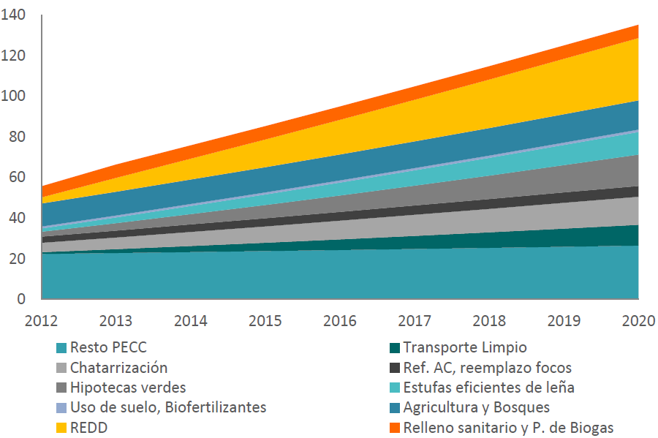

What is Included in the “Urban” Sector?
The Urban NAMA is an initiative administered and implemented by the Federal Government of Mexico that will incentivize low emission and efficient community developments and urban services throughout Mexico. CONAVI and SEMARNAT, in consultation with states, municipalities, and private sector stakeholders- will provide technical guidance in the form of recommended baskets of low emissions interventions and make available funds to community developers, home buyers, and municipal governments to promote sustainable development. The NAMA will also measure and report emissions reductions for the purpose of creating carbon credits that can be monetized and used to support further sustainable investment and development. The Urban NAMA is a new approach to funding low carbon development and departs significantly from previous instruments such as the CDM.
Under the Urban NAMA, an “umbrella” approach is pursued that allows the program to address those target areas that make sense for a given geography or region. From the perspective of an urban community, there are a number of potential target sectors that could be addressed, namely:
Table 2: Addressable Target Areas in the Urban “Sector”
New Building Efficiency | Sewage Treatment | Water Delivery | Public Lighting
Existing Building Efficiency | Solid Waste | Transport | Electrical Infrastructure
However, not all of these sectors can be covered by the Urban NAMA at the program inception due the cost and complexity of implementing and measuring such a broad ranging program. Furthermore, it is the goal of the Urban NAMA to generate carbon credits that can be sold to fund sustainability investments. In addition to this NAMA, there are a number of concurrent initiatives being pursued by Mexico that may directly or indirectly impact these target areas, thus some target areas may not be pursued to ensure that double counting of emissions reductions are avoided. The follow section discusses in more details the targets areas that will be pursued.
The “umbrella” concept extends beyond the discussion of target areas and is also reflected in the MRV and methodological approach underpinning the Urban NAMA. The Urban NAMA will extend the boundary of emissions measurement to the total energy, fuel and water consumption at the community level, instead of measuring each component and adding up the results. This net emissions approach will allow the Urban NAMA to account for the interactions generated when a diverse set of interventions are deployed in the same geography, both capturing synergies between technical interventions and reducing risk of double counting within the boundary of the community. The Community scale measurement proposed for the Urban NAMA can reduce MRV and methodological complexity and cost by reducing the incidents of measurement and types of data collected.

Overview of the Urban NAMA
In the previous section, all of the potential target areas in the urban “sector” were identified. In this section we discuss how the NAMA can be implemented and provide justification for pursuing this approach.
The goal of the Urban NAMA is to achieve credited GHG emissions reductions through deployment of sustainable urban communities at the national scale. Currently, two of the most successful sustainable development programs in Mexico are operated by CONAVI. These programs, namely ‘Hipoteca Verde’ (‘Green Mortgage’) and ‘Ésta es tu casa’ (‘This is your house’) provide supplemental income to cover the incremental cost of energy efficient equipment. Through their initiatives, CONAVI has established financial and operational relationships with community developers, and developed technical guidance covering the types of technologies that qualify for the financial incentives.
Figure 2: Sectoral Coverage of the Urban NAMA
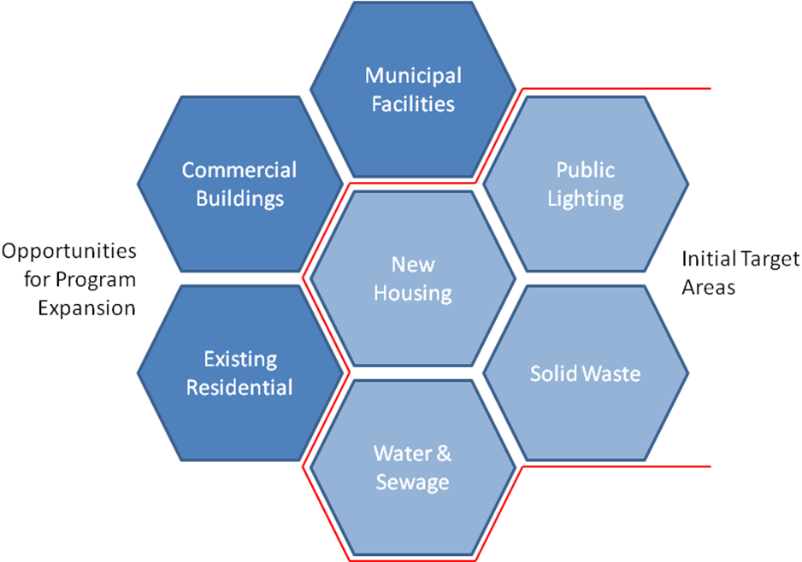
The housing developers are building large communities of between 10,000-40,000 homes, and also install the roads and supporting infrastructure that provides access to broader municipal services. Using this as the starting point, the question is: how can the relationships and structures already developed by CONAVI be leveraged to expand the scope of efficient residential developments beyond appliances to encompass whole house design and community services?
Therefore, the roll out of the Urban NAMA will focus on strengthening the work that has been done to improve the efficiency and quality of new residential development with the goal of capitalizing on reduction opportunities to improve waste, water and public lighting.
The initial focus on newly constructed communities leads to a program that is rolled out on a subset of the Urban “sector” at a national scale. Because of the umbrella approach proposed previously in this document, the Urban NAMA can eventually be “deepened” to include more target areas in the built environment as the program matures.
Although the program itself covers the whole country, the geographic boundary of individual Urban NAMA communities is sub-city with neighborhoods or housing developments as the initial scale of deployment. It is envisioned that the NAMA may “broaden” over time, growing to encompass nearby communities and eventually entire cities as the scope of efficient municipal service offerings grows.

Desired Outcomes
As previously stated, Mexico must already expand the built environment during the coming decades due the high population growth and rapid urbanization. Based on the figures presented in Table 1, and assuming no mitigation action, emissions from new housing developments attributed to the target areas presented in Figure 2 will amount to more than 60 MMtCO2e / yr by 2020. Figure 3 demonstrates the emissions attributable to new housing developments in Mexico between 2012-2020 based on the assumptions outlined in Table 1. With regards to efficiency levels, we use the extensive work that has been done to quantify the emissions reduction potential of the Housing NAMA and extrapolated the same levels of efficiency improvements across the entire scope of urban services. Additional work will be need to be completed to generate more accurate data and assumptions regarding the cost and performance of applicable technologies, as outlined in Chapter 7.
Figure 3: Emissions Pathways for New Urban Developments: 2012-2020
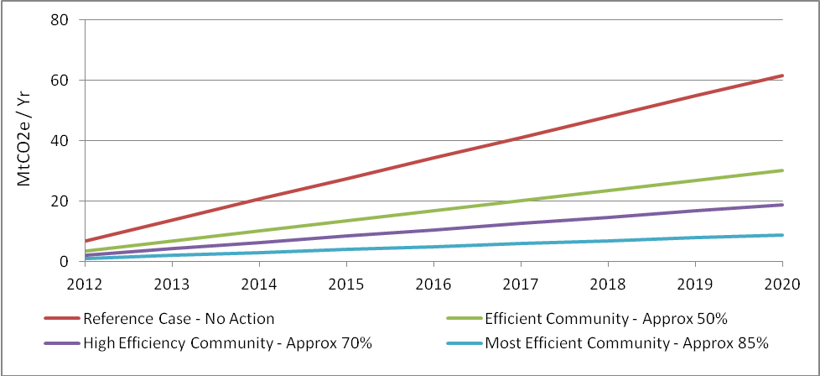
The buildings and urban infrastructure constructed over the coming years will be in-use for decades, and Mexico now has an opportunity to invest in sustainable development that will pay off for years to come in terms of energy and water savings, public health, and domestic industry.
The Urban NAMA will utilize economic instruments, including carbon credits, to supporting the mitigation, adaptation and reduction of vulnerability in the face of climate change and promote the protection, preservation and restoration of the environment; ensuring the sustainable utilization of natural resources and generating economic benefits to those who implement them. Detailed discussion on the financial structures and incentives utilized by the NAMA can be found in Chapter 4.

Non-GHG Benefits
Low emission communities contribute to better indoor and outdoor air quality, leading to health benefits. Efficient, green buildings help create healthier conditions by supporting more stable indoor climates, with less draft from windows, walls, floors, and ceiling constructions in cold climates, and better shading and ventilation for less heat encroachment in hot climates. All of these benefits result in an improvement in the quality of life of building occupants.
High quality living environments can aid in achieving other economic development goals by providing comfortable spaces that increase productivity. Furthermore, citizens living in efficient communities are likely to spend less money on lighting, heating, and cooling – savings from energy efficient homes provide additional spending for low-income residents.
In addition to being a low-cost source of GHG emissions reductions, communities with efficient water systems can be designed to increase resilience to the impacts of climate change through design construction and management.
- Improved quality of services for low-income Mexicans
- Lower cost of power and municipal services
- Health & economic benefits
- Reduced time & money needed for transport
- Eliminating the energy impact of buildings, which represent approximately 40% of primary energy use globally, is achievable and can contribute significantly to energy security and social stability
- Urban areas are particularly affected by energy trade imbalance due to high proportional building energy use
Design, construction and renovation of buildings are a large contributor to GDP & Employment – making buildings more energy efficient and operating community scale services will create additional economic opportunities and employment in the construction sector. Building communities uses large quantities of raw materials including energy, water and construction materials. Environmentally sound siting decisions and materials can significantly reduce water use and improve waste management.

International Climate Focus on Urban Systems
There has been significant interest in sustainable urban development at the international level due to the increasing urbanization of the world’s population. As Figure 4 demonstrates, in this decade we will reach an inflection point where the majority of the population in less developed countries will reside in urban spaces. This demographic shift will create demand for new urban infrastructure across the developing world, and ensuring that these assets are constructed sustainably represents a major opportunity to reduce growth in GHG emissions over the coming decades.
The UN has recognized this need and deployed a number of programs to support sustainable urban development. Key initiatives include the Sustainable Cities Programme (SCP) which is a joint UN-HABITAT/UNEP facility established in the early 1990s to build capacities in urban environmental planning and management. The UNDP, in a parallel program, offers assistance to developing country national and sub-national governments to prepare green, low-emission and climate-resilient development strategies (Green LECRDS). The formulation and implementation of Green LECRDS is intended to enable developing countries to respond more effectively to climate change and help guide conventional and innovative sources of sustainable development.
Figure 4: Urban & Rural Population in Less Developed Countries 1950-2050
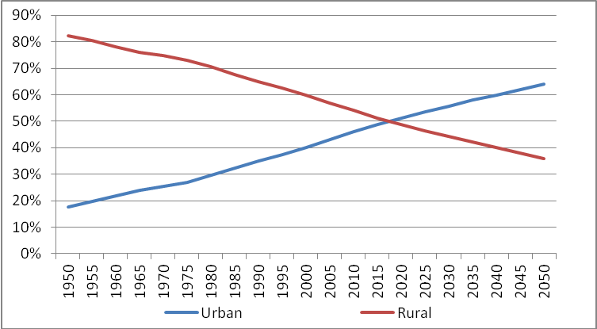
The World Resources Institute (WRI) has developed a methodological approach to promote sustainable urban development through the Global Protocol for Community-Scale GHG Emissions (GPC), a joint mission between interested stakeholders to develop an open, global protocol for municipal-scale accounting and reporting. The WRI GPC helps cities prepare a comprehensive and credible GHG inventory and develop effective strategies for managing and reducing their GHG emissions through a thorough understanding of GHG impacts from their human activities. While this approach is commendable, it is not directly applicable to the Urban NAMA due to the difference in scale and scope between the GPC approach and envisioned interventions.
Figure 5: Percentage of Urban Population and Agglomerations by Size Class, 2025
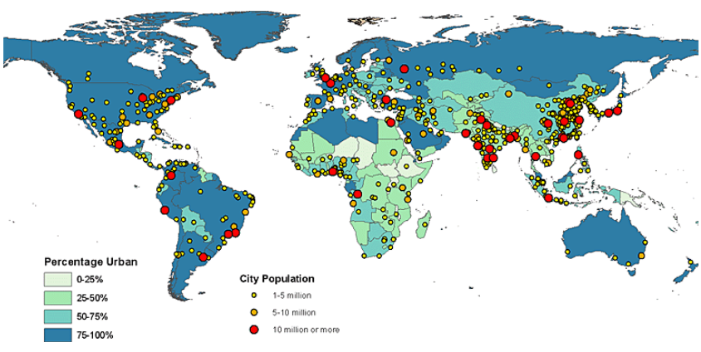
Finally, there has been action by the local government themselves through organizations such as Local Governments for Sustainability (ICLEI) and the World Mayors Council on Climate Change (WMCC), currently chaired by Marcelo Ebrard, Mayor of Mexico City. Through these groups local government leaders concerned about climate change can access technical consulting, training, and information services to build capacity, share knowledge, and support local government in the implementation of sustainable development at the local level. WMCC has also produced "The Mexico City Pact," a voluntary initiative of mayors that aims to advance climate actions. By signing the Pact, signatories commit to 10 action points, including the reduction of emissions, adaptation to the impacts of climate change and fostering city-to-city cooperation.

Policy Context, Role & Implication of the Market Mechanism
This section describes the need for an urban NAMA and its relationships to Mexican policy, institutions and related initiatives.

Why use an Urban NAMA?
In general, NAMA’s are intended to be deployed at a national scale, whereas CDM and programmatic approaches target project scale reduction opportunities. While the CDM has been an excellent program that has created many opportunities to deploy low carbon solution, the bottom-up project based approach is not appropriate to advance national climate change and sustainable urban development goals that must be deployed through government support across varying geographies with a range of payback timelines. Mexico has already passed a climate change law that leaves the door open to the future establishment of a domestic carbon market. The Urban NAMA is based on a desire to address this important area and can be enacted through existing ministries that already have the authority and mandate to improve energy and water efficiency and disburse climate related funds.
In addition to contributing to Mexico’s GHG mitigation goals, improving efficiency and providing health benefits, the Urban NAMA, by generating a demand for low-emission urban services will support development of domestic industries to provide technological and material solutions. While the strong population growth over the coming decades is expected to create strong demand for new buildings, this trend will not continue in perpetuity. The Urban NAMA creates incentive for community developers to stay and provide operational, maintenance and reporting services for sustainable communities, creating a new business model to support these entities when home sales decline.
The NAMA structure proposed in this document avoids the complexity and transaction cost associated with the CDM by aggregating the net emissions impact of many technologies in a single “sector” covering the entire county. This approach allows for a simplified MRV system that does not need to quantify the contributions of individual technologies. The NAMA is further differentiated from the Program of Activities (PoA) because the same methodology can be applied across diverse geographies that choose to implement different technical interventions.
Finally, the Urban NAMA is an approach that has broad applications outside of Mexico. Many developing countries are facing a similar situation of population and urbanization. Models developed through Mexico’s Urban NAMA can be utilized around the world to make a significant impact on per capita energy and water use.

Role of the Urban NAMA
In general, implementation of efficient communities is not dependent on the development of new technologies. Therefore, the Urban NAMA achieves emissions reductions by coordinating actions between public and private stakeholders to create technical, regulatory and financial frameworks for the deployment of efficient and low GHG emitting urban spaces. Public Private Partnerships (PPPs) between the private sector, federal, state, and local governments that are developed under the NAMA will enable access to additional sources of commercial funding in addition to generating carbon credit revenues. Critical to the Urban NAMA will be the implementation of an MRV system so that carbon finance can be attracted to supplement public and private investment and performance based funding can be accessed.
A key role of the Urban NAMA will also be to develop economic instruments and structures to support sustainable investments. Discussed in greater detail in Chapter 4, the goal of these structures is two-fold. The Urban NAMA will implement payments for environmental services that can be used to generate new revenue streams based on the sale of carbon credits. These revenue streams can then be leveraged to access commercially available funding from institutions such as the Sociedad Hipotecaria Federal (SHF) and Banco Nacional de Obras y Servicios Públicos (BANOBRAS) have made funds available for the deployment of efficient communities that local governments, the current providers of urban services, cannot access due to weak financial positions.
Under the NAMA, SEMARNAT and CONAVI will play another key role by creating clear standards and technology packages that community developers and urban planners can use to access supplementary funding. Under the current CONAVI programs, housing developers know exactly which technologies need to be installed to access the green subsidies; this provides certainty for these stakeholders and clearly demonstrates the value of these technologies to potential home buyers. The NAMA will pursue a similar structure but developing and promoting “baskets” of technologies, discussed in Chapter 5, appropriate for each climate zone in Mexico.
The Urban NAMA will play a role training builders so that they can properly install, operate, and maintain the low carbon technologies. Furthermore, the NAMA will certify 3rd party vendors to inspect community developments during the construction process and verify the collected emissions data. These steps will help ensure that Urban NAMA interventions installed perform as expected and that climate based finance is achieving the necessary emissions reductions.

Preliminary Design of a Scaled-Up Urban NAMA
The NAMA is a national top-down program that will be administered by SEMARNAT and CONAVI to connect funds and technical support to local stakeholders to incentivize low-emission and efficient urban communities that will help Mexico achieve broader sustainable development goals as well as its GHG objectives.

Coverage of the Urban NAMA
The Urban NAMA as it is defined in this document covers community scale mitigation actions applied for new, green field residential communities across Mexico that (1) reduce demand for delivered services, or; (2) improve the emissions efficiency of delivered services. The sectors that comprise the community include:
- New Housing –The scope for this sector is focused on new construction and includes: a) Methods that can reduce the electrical and thermal energy consumed by the house, b) Methods for reducing water consumption and sewage generation by the house and c) Methods for reducing solid waste generated by the house.
- Waste – The scope for this sector includes: a) Methods for reducing the amount of waste and sorting waste at the housing level, b) Methods for minimizing emissions from collection and transportation of waste from the home to a community level sorting facility, c) Methods for minimizing emissions from transporting sorted waste to three end points (recycling, incineration and landfill), d) Methods for minimizing the amount of waste sent to incineration and or landfill facilities, e) Methods for minimizing emissions at each of the end points which may have co-benefits for generating energy for the community in the case of incineration and landfill approaches.
- Water – The scope for this sector includes: a) Methods for minimizing the energy and reducing the amount of water required by the community, b) Methods for minimizing the energy and reducing the amount of sewage generated by the community and c) Methods for downstream processing of the sewage which has co-benefits of reducing water consumption while generating useful energy for the community.
- Public Lighting – The scope for this sector includes: a) Methods for minimizing energy consumed by the light and optimizing geographic placement of lights to minimize energy.
Examples of technologies that can be applied to meet the energy and emissions reduction objectives outlined in the scope have been identified in Table 6. However, as part of the Pre-Pilot development outlined in Chapter 7 additional work is needed to evaluate the potential technology options for each of Mexico’s four climate zones and develop comprehensive and effective interventions.

Relation to- and Integration with, other Initiatives
The umbrella approach of the Urban NAMA provides flexibility for implementers and the opportunity to align NAMA activities with broader development goals. Furthermore, the community level accounting allows for many different types of interventions and locations to be included under the same NAMA, reducing implementation and transaction costs while providing synergies and consistency. However, Mexico is pursuing multiple sustainable initiatives that may directly or indirectly impact the actions taken in the Urban NAMA target areas.
The community scale accounting approach delivered by the Urban NAMA enables implementation of communal waste, water, energy efficiency measures or small scale renewable energy installations. The distinction between parallel actions that affect similar target areas segments is critical because the Urban NAMA will aggregate actions across the entire community and measure the net impact on fuel, water, and energy use. These important and cost effective solutions can be lost through traditional methodologies that measure only the emissions from a housing unit, but the NAMA must be careful to avoid double counting improvements to these systems not attributable to the program.
In this section we provide a brief overview of potential interactions and explain how double counting of emissions reductions can be avoided.
- New Housing – Mexico is also pursuing a supported Housing NAMA focused on improving the design of low income homes and promoting the use of efficient appliances. While these same technical interventions may be used in the Urban NAMA, a Housing NAMA cannot operate in the same geography. In instances where the Housing NAMA is “expanded” to include municipal services, all emissions reductions resulting from actions within the building envelope will be accounted through the broader community measurement system.
- Waste – Mexico may also pursue a Waste NAMA that focuses on downstream treatment of solid municipal waste. While there is no inherent conflict between the two, in any case where an Urban NAMA produces waste that is delivered to a Waste NAMA facility, the emissions reductions generated at the community level will need to be accounted for in baseline of the Waste NAMA facility.
- Water – While we have not identified any specific programs that would conflict with the Urban NAMA’s treatment of water and sewage systems, under a scenario in which regional water-specific initiative impacts the delivery system to an Urban NAMA community, the reductions attributable to the outside initiative will need to quantified in the community baseline.
- Sewage – the PECC has identified the generation of biogas from sewage as a target area in the 2013-2020 roadmap (see Figure 1). Urban NAMA actions that reduce creation of liquid municipal waste will need to account for the downstream treatment of that waste when calculating the emissions impact.
- Public Lighting - While we have not identified any specific programs that would conflict with the Urban NAMA’s treatment of public lighting, under a scenario in which a public lighting initiative impacts an Urban NAMA community, the reductions attributable to the outside initiative will need to be quantified in the community baseline.
- Power Delivery – While the Urban NAMA will not focus on electrical infrastructure or generation, many of the emissions reductions will be achieved through reduction in electricity demand. External actions that impact the emissions intensity of delivered power, such as the installation of renewable assets, will need to be quantified in the community baseline.
- Refrigeration – Mexico is targeting refrigerators in a parallel NAMA that will impact the HFC emissions and energy use by units in Mexico. Under a scenario in which ‘NAMA refrigerators’ were installed in ‘NAMA communities’ their impact on energy use could lead to double counting. Under this scenario, Mexico will need to decide whether (1) the energy efficiency component of the refrigerator would be rolled into the Urban NAMA emissions accounting, or (2) the Urban NAMA would need to adjust the crediting baseline to account for improved refrigerator efficiency.

Interaction with CDM
There are currently 44 active CDM projects in Mexico that are generating Certified Emissions Reductions (CERs).
Figure 6: Sectoral Distribution of CDM Projects in Mexico
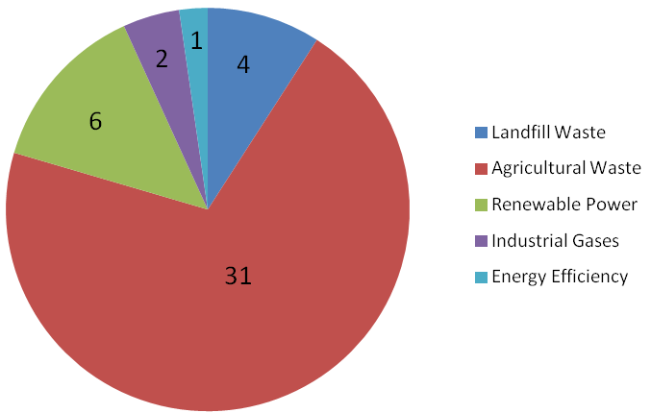
Of these projects, only the landfill waste and renewable power projects have the potential to interact with the Urban NAMA through altering the emissions intensity of waste and electicity attributable to a NAMA community. In these cases, adjustments to the base case will be required to avoide double counting of emissions reductions.

Boundary of the Urban NAMA
In order to facilitate accurate measurement of emissions reductions and generate saleable carbon credits, a clear set of rule are needed to clearly define the sectoral and geographic boundary for the Urban NAMA.
Sectoral Boundaries:
- The new housing sector is meant to encompass only new construction of three different types of housing units Aisalda, Adosada and Vertical. It does not include other types of buildings within the community (e.g. convenience stores, municipal buildings etc.).
- The waste sector is meant to include all of the upstream (e.g. collection), midstream (e.g. sorting) and downstream (e.g. incineration) activities within the boundaries of the community. Actions occurring outside of the community will not be accounted, this boundary condition will be carefully managed to avoid double counting with regional initiatives developed through a Waste NAMA.
- The water sector boundary does not extend past water demand and sewage generation at the community scale. Actions that improve the efficiency of regional water and sewage processing would not be covered by the Urban NAMA, but would need to be accounted in the community baseline.
Geographic Rules:
- During initial implementation, there should be minimal geographic overlap between an Urban NAMA and a Housing NAMA. Future versions may incorporate Urban NAMA measures in what was previously a Housing NAMA community with the caveat that credits that result from emissions reductions at the housing level would be considered invalid if the Urban NAMA ends up being a credited NAMA.
- The set of preferred measures for each community will need to be customized based on climate zones (currently anticipating four) and potentially hydrological zones (to factor in for water sourcing).
Figure 7: Mexico’s Climate Zones
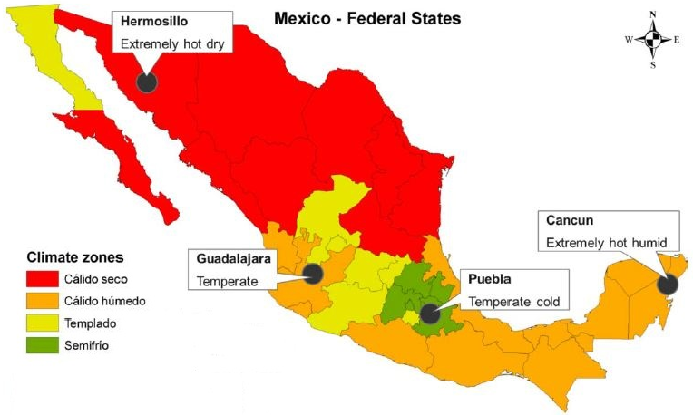

Leakage from Urban NAMA Activities
Carbon leakage occurs when there is an increase in emissions outside of the program boundary resulting from the mitigation actions taken. Because the Urban NAMA focuses primarily on improving the efficiency of energy, waste, water, and sewage consumption within new residential communities it is difficult to envision specific impacts these actions would have on non-NAMA communities.

Operational Design Elements
The Climate Change Law allows for the Federal, State and local governments to subscribe coordination or collaboration agreements in matters of climate change. This collaboration will include the locations, objectives and financial contributions for which each party is responsible. The law stresses that integrality and transversality (coordination and cooperation) across different levels of government and with social and private sectors should be pursued to ensure a nation-wide scope in the instrumentation of the national policy for climate change.
The goal of the Urban NAMA is to mitigate emissions and thus contribute to Mexico’s GHG objectives; it also aims to improve quality of life for Mexican citizens, promote sustainable economic development, and support domestic industries. In order to achieve these goals the NAMA must engage stakeholders from across the public and private sector. In this section, we discuss the operational and financial structures of the Urban NAMA, identify important stakeholder groups, discuss their role in the NAMA, and describe their motivation to participate.
Figure 8: Operational Overview
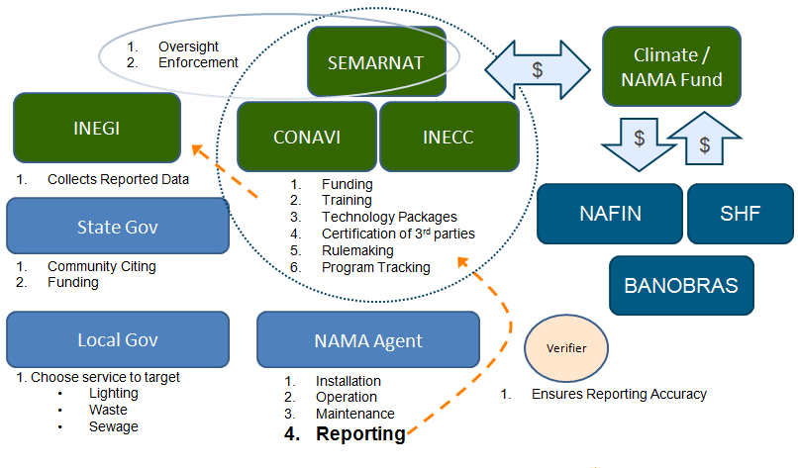

Federal Government
Figure 8 below illustrates the overall operational structure of the Urban NAMA. The cluster of Federal Government agencies that comprise the NAMA office will coordinate and oversee the NAMA. In addition, this group will monitor program performance, including MRV, and bring enforcement action in the case of misconduct. As illustrated in Figure 9 in the following section, this cluster of entities will act as the sole “selling” counterparty of emission credits resulting from the Urban NAMA. This reflects the fact that the NAMA is a national program, and as such outside investors would be participating in the entire program, not just in a specific community.
CONAVI or SEMARNAT will make up the core of the implementing body and play a central role in the program through rulemaking and by providing funding, training, technical guidance, and certifying 3rd party verifiers. Overall NAMA performance is ultimately reporting to the Instituto Nacional de Estadística y Geografía (INEGI) for incorporation into Mexico’s emissions inventory and broader international reporting.

State & Local Governments
State and Local government also has a critical role to play. Under the Climate Change Law, State governments have the mandate to formulate, regulate, direct, and instrument mitigation and adaptation action on territorial ordinance in human settlings and in urban development of population centers. Because of this attribution, state governments should help direct the siting of the Urban NAMA by choosing candidate urban areas for program implementation, in collaboration with the federal and municipal authorities. State governments can play a funding role through management of their own funds to support and implement Climate Change development actions. State funding along with complementing revenues from the NAMA credits and federal funds, can also be used to capitalize public private partnerships, to implement MRV oversight capacity, and to train personnel.
Local governments will play a critical role in the operation of the program because any action taken by the NAMA at the community level will need to interface directly with the surrounding area and infrastructure. Furthermore, under the Climate Change Law, local governments have the mandate to draft and instrument policies and actions to confront climate change in drinking water and sanitation, local environmental ordinance and urban development, and municipal services. Local governments will also provide input on NAMA interventions by advising on the low emission urban services to be included in a given community.

NAMA Agent
The key operational relationship is between the federal program implementer and the NAMA agent operating at the community level. As Figure 8 illustrates the NAMA agent reports directly to Federal Agencies and is responsible for the day to day operation of the community’s NAMA equipment/actions. They will also have to coordinate with local governments to integrate efficient delivery of municipal services with the broader municipal infrastructure and ensure accurate reporting of program impacts.
At the individual community level, a NAMA agent will be responsible for the installation, operation, and maintenance of the low emission technologies and services approved under the NAMA; as well as reporting to the federal government emissions from the NAMA community. In the further design of the Urban NAMA, it will be determined whether this reporting will be verified before submission, or through a random auditing process.
Community developers have been suggested as the NAMA agent for the launch of the NAMA because they are already constructing the homes and infrastructure that Urban NAMA activities will seek to influence. Under “baseline” circumstances, the community developer has no incentive to remain in the community once the houses are sold.
In the Urban NAMA, payments for environmental services and other forms of financial support create an incentive to the developer to install, operate and maintain efficient technologies in new communities. This is beneficial for the communities as municipal governments’ budget are insufficient to ensure these services, and would generate a new line of business for the private entities which face declining demand for new homes over the coming decade, all while contributing to sustaining GHG mitigation.

Financial Design Elements
The Urban NAMA blends public funds, climate finance and carbon credits to leverage commercially funding through PPPs to support sustainable development. Carbon credits are a key element to the success of the program because they allow the Federal Government to monetize the climate benefits generated under the Urban NAMA, creating an additional revenue stream that can be used to strengthen the financial case for low carbon investments made by community developers and private financial institutions.
However, the Urban NAMA will not be solely supported through the sale of carbon credits, nor are saleable credits the only source of economic value that will be generated. It is expected that “unilateral” funding from the Mexican government will be supplied and partly funded by the green fund described in the Climate Change Law, and possibly funded through savings to the government resulting from decreasing energy subsidies.
Elements of the NAMA may be “supported” through loans and grants from development banks, multilateral institutions, and foreign governments. Under a performance-based “supported” paradigm, the measured impacts of the NAMA are used to attract sustainable development funding without the issuance of credits.

The NAMA Fund
The central financial element of the Urban NAMA is the NAMA fund. This fund is managed by the NAMA office, made up of SEMARNAT, CONAVI and other appropriate federal entities, and will provide loans, loan guarantees, and grants to private sector stakeholders and Mexican Citizens to support sustainable urban development. The Urban NAMA will support both the supply and demand side of the market for sustainable communities; reducing uncertainty and risk for the NAMA agent, potential home buyers. For investors, this approach reduces overall performance risk by ensuring that the market is robustly supported and balanced.
In addition to providing funding to the private sector, the NAMA fund can be used to strengthen the balance sheets of local governments, thus providing easier and less expensive access to commercial financing. NAMA funds may also be used for capacity building at the state and local level, training and certification of NAMA agents and verifiers, and the development and operation of an MRV system.
The fund will initially be capitalized by the federal government, ideally with the support of national and international development banks, private investors and partner governments. The NAMA fund will also raise funds through the monetization of emissions reductions generated by the Urban NAMA. A critical design feature that needs to be clearly defined is how private investors can get involved and how they can access credits generated by the program. Because the Urban NAMA is a national program and not a project-based approach, buyers of carbon credits will not be able to invest in specific communities.
Instead, carbon finance can be accessed through direct sale of carbon credits on an exchange or bilateral agreement. The NAMA could also deliver carbon credits through more innovative instruments such as issuing green bonds or selling “shares” in the fund where the investor receives a portion of the credits generated based on the size of their investment.
Figure 9: Financial Overview
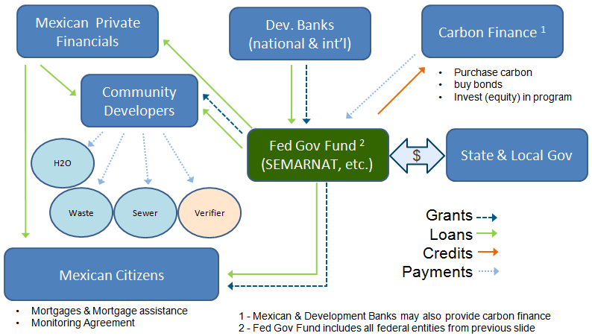

Financial Sector
Private finance also has a role to play under the envisioned Urban NAMA. In fact, due to funding constraints on public stakeholder, private sector finance will be needed to deploy sustainable communities at the national scale. In accordance with the Climate Change Law, the Urban NAMA can work to engage private sector participants. By stipulating the eligible low emission technologies and providing financial support, the NAMA creates a favorable environment for private sector stakeholders to engage in urban sustainability.
Under the Urban NAMA community developers will deploy low carbon technologies that have higher up-front costs, but a positive return on investment over the life of the community. The higher cost of construction will create greater demand for commercial loans and bridge loans to finance low carbon development and to sustain developers in the period between that construction and sale of homes. Higher development costs will also lead to higher home costs and larger mortgages.
Despite the higher cost of efficient communities, the long term economic value of sustainable communities has already been recognized by major financial institutions in Mexico. Table 3 below illustrates major financial entities and how they may participate in the NAMA.
Table 3: Select Financial Players in Mexico
Institution | Mandate | Potential NAMA Role
SHF | 2nd tier bank provided capital to mortgage lenders | Support traditional mortgage lenders providing NAMA mortgages
BANOBRAS | Infrastructure Bank | Finance for community developments & infrastructure
INFONAVIT | Housing finance for low income funded by payroll tax | Provide NAMA mortgages to low income Mexicans
Traditional Bank | Commercial loans and mortgages | Finance for Community Developers and Mexican Citizens

Multilateral Institutions and Foreign Governments
Many multilateral institutions, development banks, and foreign governments have expressed interest in supporting sustainable development and some have even earmarked funds for this purpose. These entities can play a role in the Urban NAMA by providing grants and soft loans to capitalize the NAMA fund, or by funding capacity building and MRV infrastructure development. Entities that have an appetite for carbon instruments can also provide carbon finance through the purchase of credits. Development banks and multilateral institutions provide may also directly fund implementation actions such as those described in Chapter 7 or assist in technology transfer.

Barrier Analysis
Despite the many benefits of sustainable urban communities, there are significant barriers that keep the Mexico from applying these measures which the NAMA will address. These barriers fall into four general categories: financial, institutional, political and technical.

Financial Barriers
Low emission homes and communities require more up-front investment than a “baseline” community. The increased capital cost is a significant barrier to development, especially for the low-income segment where the greatest demand for new communities is projected over the coming decade. Even when this barrier is not a constraint, lack of information about the long term economic benefits of efficient design may make Mexican citizens unwilling to secure the additional financing required.
Financial barriers to the demand side of the market also result in risk and barriers for the community developers who supply residential communities. Developers must finance their operations through commercial loans or their own savings. If they are not able to recoup the incremental investment in low carbon communities, or if they take longer to sell, developers may not be willing to deploy them or may be unable to finance the incremental cost of low carbon developments.
Moving up the value chain, local municipalities, generally the responsible parties when it comes to urban services, are unable to afford the higher capital cost of low-carbon technologies due to severe ongoing budget constraints and weak balance sheets that prevent them from accessing commercially available funding.
The Urban NAMA will address these financial barriers by using the NAMA fund to provide supplemental finance to both the supply and demand side of the market for residential communities. This finance can be used to cover the incremental cost of efficient equipment for citizens and community developers, which will also relieve the burden on local municipalities. The NAMA will also work with municipal governments through public private partnerships, blending public money with private funding and grants to strengthen the financial position of local governments so that they can also access traditional sources of finance.
The NAMA will be able to provide this financing because it will generate revenue through the sale of credits in the international carbon market and generate savings to the Federal Government through reduction in electricity and fuel subsidies. Furthermore, because the NAMA is a low-carbon development program, the credits and associated MRV of performance may help Mexico leverage international grants and soft loans targeted at sustainable development for urban application.

Institutional Barriers
Currently Mexico has insufficient capacity for the measurement and reporting of community scale interventions, making it difficult to measure with certainty the performance and impact of energy efficient and low carbon communities, a pre-requisite to monetizing the benefits generated across the public and private economy. For this reason, it is difficult to make the economic argument in support of efficient technologies and to access performance based climate finance. Furthermore the providers of urban services, local governments, have limited incentive to plan beyond a single 3 year term due to term limits.
The Urban NAMA aims to address these barriers by establishing a robust MRV framework that will enable the program to quantify benefits across emissions, cost, and public health benefits clearly demonstrating the value of the technologies and serving as a basis for saleable credits. In addition, it is envisioned that the NAMA will shift some of the burden of providing municipal services onto the NAMA agent, an entity, in this case, that can take a longer view of the investment than the local government.

Policy Barriers
The major policy barrier facing the implementation of energy efficient systems in the urban environment is a lack of regulatory framework to incentivize efficient design and use of energy and urban services. In fact, the federal government currently subsidizes residential power and natural gas use for low-income citizens. The result is that low emission and energy efficient equipment has an even longer pay back for the end-use period because cost savings are shared with the federal government, and may make some technologies unattractive.
The NAMA deals with this barrier by creating a new set of incentives for the use of low emission efficient technologies, such as mortgages with favorable terms linked to NAMA communities, and by assisting with the up-front capital cost through grants or other assistance. In addition, the program feeds back savings to the federal government through avoided subsidies that can be targeted towards sustainable economic development, reinvested into the NAMA fund, or used for clean technology investments in other sectors.

Technical Barriers
There are three key technical barriers that need to be overcome; (1) the lack of standards for efficient urban design, (2) insufficient domestic capacity to supply efficient equipment, and (3) an education or training gap for community developers for the installation of the technologies.
The NAMA will directly address the first and third technical barriers by creating technology packages to address the four climate zones and different types of urban communities and training community developers on their implementation. Through this process, the community developer will access to pre-approved urban designs that can be applied in their developments. These approaches will be standardized so that the NAMA implementer and NAMA agent will be able to accurately estimate the cost and return of efficient designed before breaking ground in a given region.
The NAMA will address the second technical barrier indirectly because it is not envisioned that part of the program will be to provide manufacturers of efficient equipment with direct assistance. However, by creating demand for efficient communities and by providing pre-approved technology packages the program will create a clear demand signal for industrial players that want to enter the market and reduce their risk for developing manufacturing capacity.

Potential for Market Linkages
The Urban NAMA is developing under the assumption that the international community provides a demand leading to a revenue stream for achieved emission reductions under the NAMA. Under such a scenario, Mexico would be in a position to produce NAMA credits that could be used by foreign governments or private companies to meet emissions reduction obligations – or may be retired to contribute to further global net mitigation. In the absence of a multi-lateral treaty that creates a global market for NAMA credits, such instruments could still be sold bilaterally, provided to donor governments in exchange for climate finance, or used as part of a broader program to support sustainable development in Latin American and Caribbean countries.
If no such international market is available, Mexico may also create domestic demand for NAMA credits by allowing them as a method of compliance if specific entities are charged with achieving emissions reductions in line with the ambitious goals detailed in Mexico’s Climate change law. No such mandate exists at this time, and the decision to enact such a system is beyond the scope of the Urban NAMA.

Technical Design of the NAMA

This section covers the technical and methodological approaches the Urban NAMA might employ, recommends existing structures to the extent possible, identifies gaps and needs in these approaches, and describes needed actions for the implementation phase of the NAMA.

Overview of Data Sources in Mexico

Determining emissions reductions in the Mexican urban sector requires the calculation of two separate but linked emissions profiles. The baseline emission profile originates from an understanding of GHG emissions from typical activities that would occur absent this investment in GHG mitigation, being sure to account for parameters such as climate, number of occupants, and size of the dwellings. The actual emissions can be calculated by tracking the measurements and activities on the community site(s), and then extrapolating the associated emissions from those activities. The difference of the two is the emissions reduction of the activity or system.

The data and modelling needs for the above metrics can be complex, but there are already existing resources to build upon. Most significant are the methodologies developed by the CDM, which provide assumptions, formulas and models for reductions. This Urban NAMA departs from previous CDM methodologies by taking a holistic view of overall efficiency of the included areas and not simply calculating the specific effect of discrete interventions. In this context, it’s extremely important to understand and account for all the components that drive consumption, to isolate the reductions only arising from reduction activities. CDM’s focus on accounting for each individual component means that these methodologies will not be appropriate for the Urban NAMA. Additional work will need to be done to develop quantification methodologies that take into account data availability in Mexico the indirect emissions arising from waste diversion, water transmission and water usage.

Much of the data needed to estimate the emissions resulting from residential communities can be found in Mexican agencies such as SEMARNAT, the Secretaría de Energía (SENER) and CONAVI. As well, the United Nations, USEPA, World Bank, and Environment Canada have tools and datasets that are applicable. Table 4 below lists some external data needs, and the sources that can be used. Table 4 excludes the data directly measured on the activity site(s), which will be dealt with in section 5.3.

There are a number of calculations and data sets that need to be developed in order to measure the impact of this NAMA. Most difficult will be normalizing for factors (outside of the emission reduction activities) that affect consumption and waste measurements. Models exist, such as Environment Canada’ model (HOT-2000) which takes factors and translates that into residential energy efficiency, but it would need to be revised for the Mexican market. Micro-data sets focusing on average household data will need to be gathered, and the model will need to include assumptions specific to the Mexican housing stock, behaviour, and climate.

Table 4: External Data Needs for the Various Activities (not all-inclusive)
External Data Needs (not all inclusive) | Potential Sources and Applicable Studies
Average (BAU) power consumption, natural gas consumption, other residential fossil fuel consumption, water consumption, solid waste emissions for reference residential household | - UNEP, http://www.unep.org/sbci/pdfs/SBCI-Mexicoreport.pdf  - SENER: SIE (Sistema de Informacion Energetica), http://www.sener.gob.mx/portal/Default.aspx?id=1428  - CONAVI  - SEMARNAT, http://www.semarnat.gob.mx/informacionambiental/badesniarn/Pages/badesniarn.aspx
The effect on consumption/emission, based on a variety of factors: climate/HDD/CDD, occupancy, size, energy prices, water prices, income of occupants, GDP, geography | - Rosas-Flores: Recent Trends in Mexican Residential Energy Use, http://www.sciencedirect.com/science/article/pii/S0360544210000174  - Environment Canada: Residential Energy Use model HOT-2000, http://oee.nrcan.gc.ca/residential/new-homes/r-2000/standard/5577  - Wolfram: How Will Energy Demand Develop in the Developing World, http://ei.haas.berkeley.edu/pdf/working_papers/WP226.pdf  - Davis, Cash for Coolers, http://ei.haas.berkeley.edu/pdf/working_papers/WP230.pdf
Emissions intensity calculation for power, natural gas, other residential fossil fuels, water, waste water, solid waste | - SENER, http://www.energia.gob.mx/webSener/portal/Default.aspx?id=1430  - SEMARNAT, http://www.semarnat.gob.mx/informacionambiental/badesniarn/Pages/badesniarn.aspx
Distribution losses/efficiency for power, natural gas, waste water, solid waste | - SENER, http://www.sener.gob.mx/portal/indicadores_de_cfe_y_lyfc.html,
Average power consumption of landfill gas operation, fossil fuel usage per mile/km for standard garbage truck, average distance from house to landfill and number of times the trash is picked up | - EPA: Mexico Landfill Gas Model, http://www.epa.gov/lmop/international/tools.html#a04

Framework for Evaluating Interventions
A key component of the Urban NAMA will be the creation, by CONAVI & SEMARNAT of mitigation packages that utilize multiple low emissions urban technologies specific to the climate zone and community characteristics. This top down approach necessitates a robust framework that CONAVI and others can utilize to perform a quantitative assessment of the technical mitigation options and prioritize the most actionable and high impact opportunities. Furthermore, this assessment should enable development of “basket” approaches that capture synergies between interventions.
Discussion of potential options must necessarily focus on specific technologies and interventions, not on broad sectors, so that an accurate assessment of performance, return, emissions reductions and non-GHG benefits can be performed. This evaluation will allow CONAVI develop effective and compelling community-scale technology packages that can be marketed to investors and housing developers.
In collaboration with SEMARNAT, CONAVI, and the World Bank team, we have identified key parameters for this assessment, and recommended a methodology for their evaluation that rates specific technologies across key performance indicators over the short, medium and long term. The purpose of this analysis, which will be undertaken in Phase 1 of the implementation plan described in Chapter 7, is to provide transparency and comparability to a large range of technical interventions that may be employed to reduce emissions in residential communities. This evaluation will result in a score for each technology and will be useful for developing the technology baskets described in Phase 2 of the implementation plan.

Table 5: Indicative Framework for Technology Evaluation for Urban NAMA

Category | Description | Potential Metrics
Reduction Potential | Emissions, energy, water, and fuel reduction achieve relative to baseline technology. | High: >50%  Medium: 21-49%  Low: <20%
Data Availability | Availability of historical data to support accurate baseline and measurement of technology impact | Collection system in place: yes / no  Relevant data collected: yes / no
Cost of Intervention | -- | * Requires MACC Analysis
Capital Cost | Up-front cost of purchasing and installation relative to baseline technology | High: Cost increase >50%  Med: Cost increase 21%-49%  Low: Cost increase <20%
Operating Cost | Operating and maintenance cost relative to baseline technology on an annual basis | High: Cost increase >50%  Med: Cost increase 21%-49%  Low: Cost increase <20%
MRV Implementation | Existence of data collection infrastructure and methodology to measure impact of the technology | Data infrastructure in place: yes / no  Methodology in place: yes / no
Participant | -- | --
Local Capacity | Ability of the technology to integrate in the broader municipal services infrastructure | Integrates with local infrastructure: yes / no
NAMA Counterparty Capacity | Technical capacity of the NAMA agent to install, operate, and maintain the technology | Installation: yes / no  Operation: yes / no  Maintain: yes / no
Strategic Fit | -- | --
National Capacity | Domestic capacity exists to manufacture the technology | High: Capacity exists & sufficient production  Medium: Insufficient capacity OR production  Low: No Capacity
Local Coordination | Support of the technology in the broader local development plan | Fits in development plan: yes / no
National Program | The technology is aligned with the National Climate Change Program and Strategy of Mexico | High: quantifiable benefits & aligned  Medium: Qualitative benefits OR unaligned  Low: Qualitative benefits & unaligned
Community Benefits | The technology generates non-GHG benefits for the community that align with national development goals | High: quantifiable benefits & aligned  Medium: Qualitative benefits OR unaligned  Low: Qualitative benefits & unaligned

Overview of Technical Options

CONAVI and SEMARNAT have identified waste, water, and lighting as the first target areas to address through the Urban NAMA, below we cover some technical options available. As described in Chapter 7, additional work will be done to evaluate the technologies which are the best fit for the Urban NAMA.
Table 6: Overview of Technical Options for Target Areas in Urban NAMA
Sector | NAMA Attribute | Examples of Applicable Mitigation Technologies
New Housing | Electricity Generation & Consumption | Solar PV, micro-wind, fuel cells, micro – combined heat and power (CHP), high efficiency lighting (e.g. CFLs, LEDs etc.), High efficiency appliances (e.g. televisions, refrigerators, air conditioners, computers etc.), ground source heat pumps, solar thermal heating, biomass thermal heating, demand side management techniques (e.g. occupancy sensors for lighting, heating, ventilation and cooling, cut off switches for parasitic power etc.), smart meters
New Housing | Gas Consumption | High efficiency boilers, high efficiency gas appliances (e.g. cooking stoves, heaters etc.)
New Housing | Water Consumption | Low pressure shower heads, rain water collection systems (for water reclamation), smart meters
New Housing | Sewage Generation | Low flush toilets
New Housing | Waste Generation | Waste sorting bins
Public Lighting | Electricity Generation & Consumption | Solar PV, micro-wind, high efficiency battery chargers, high efficiency lighting (e.g. CFLs, LEDs etc.), sunlight sensors
Public Water & Sewer | Electricity Generation & Consumption | On site power generation (e.g. solar, wind, CHP, biogas) at water and sewage treatment plants, high efficiency heating and cooling systems (at the facility), conduit hydropower, high efficiency pumps and compressors, solar desalination (where thermal desalination technologies used), flow metering equipment on water transmission and distribution lines (to detect leakage), high efficiency/throughput membranes (for various types of purification systems)
Public Solid Waste | Electricity Generation & Consumption | On site power generation (e.g. solar, wind, CHP, biogas), high efficiency heating and cooling systems (at sorting, incineration, landfill and recycling facilities), municipal solid waste (MSW) power generation, land fill gas power generation
Public Solid Waste | Gas Consumption (includes fuels for transportation) | Natural gas and alternate fuel vehicles
Public Power | Electricity Generation & Consumption | Community scale power generation (from district CHP, large solar PV, wind, fuel cells etc.), smart meters, high efficiency transmission and distribution systems, automation and control systems for on demand power dispatch
Note: The actual facilities used for water generation, sewage management and waste management can also employ some of the other gas & water consumption as well as sewage and waste generation techniques that have been presented as options in the new housing section. A more comprehensive list of applicable measures needs to be developed in Phase 2 for each sector.

Definition of Crediting Baseline
The section outlines the assessment and approaches that can be used to determine reference level emissions against which crediting baselines and community performance can be measured to ensure that net emissions reductions are achieved by the Urban NAMA.
Figure 10: Reference Levels vs. Crediting Baseline
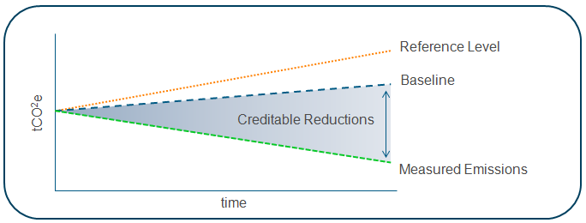
Figure 10 above illustrates the concept of reference levels, measured emissions (i.e. total reductions possible) and the crediting baseline as can be applied for the urban NAMA or any other NAMA.
The reference level is a forecasted emissions footprint for an urban community assuming that the current trends continue in terms of electricity, gas and water consumption as well as sewage generation and waste generation. A reference level can be developed for the Urban NAMA by estimating what it is for a community today and extrapolating that to capture a collection of similar environments that will likely comprise the overall initiative. This reference level will then need to be forecasted out for 10 years which would factor in the deployment of additional communities over a 10 year period. So for example if a community today is measured to have a footprint of 0.1 M tons CO2 annually today and there are 20 such communities the current year reference level would be 2 M tons CO2. Also if it is anticipated that there would be 50 such communities in 10 years, that would imply 5 M tons CO2 would be the reference level if current practices are followed in deploying communities. Based on improvements that are made on an annual basis or the course of many years, it is possible for the reference level to change. Constantly changing the reference level on an annual basis can cause considerable confusion so it is important to fix both the initial year (e.g. 2013) and the period (e.g. 10 years) over which the reference levels are forecast and develop the crediting baseline and total emissions reduction possible for the urban community based on these assumptions.
The total emissions reduction that is possible for the urban community will be total emissions that can be achieved based on all of the reduction methodologies applied for electricity, gas and water consumption as well as for sewage generation and waste generation. It is possible that some methodologies are easier to accomplish than others which is why reductions achieved can increase over time. So for example, electricity and gas consumption can be developed by building on the methodologies that have been developed under the CDM. There are fewer methodologies developed for water, sewage and waste. This implies that in a 10 year period (fixed when determining reference levels), reduction measures will be gradually phased in creating a total reduction possible on an annual basis. The phasing in of measures also has an implication on the crediting baseline that is used to create a creditable NAMA. The crediting baseline also estimated on an annual basis for 10 years is in effect a reduced emission level that is not only achievable but can also be measured and verified to an accuracy level that is deemed appropriate for generating credits.
The crediting baseline is typically set at a level that is higher than the maximum potential emissions reduction but lower than the reference level. This can be to account for concurrent actions that might show up in measured power, water, and waste parameters of an Urban NAMA community, or to ensure confidence that any emissions credits sold as a result of the NAMA represent net emissions reductions. Setting the baseline below the reference case may also be a for dealing with uncertainty in emissions accounting to ensure that all credits represent legitimate emissions reductions in target areas that are more difficult to measure.
The key considerations in determining the correct crediting baseline includes:
- Availability of emissions reduction measures and standards that can generate credits in the near term (0-2 years), mid term (3-5 years) and long term (>5 years).
- Economic drivers for the adoption of specific emission reduction measures (e.g. marginal abatement costs).
- Frequency with which crediting baseline must be revisited and revised (e.g. should it be every 2 years) based on availability of new measures and standards, changes in international, national and regional regulatory regimes and policies.

Quantifying the Reference Cases & Crediting Baseline
The Urban NAMA will comprise of four major areas which will require additional work in the subsequent phase to establish the baseline and approved greenhouse gas mitigation measures that can move towards establishing an associated MRV and crediting mechanism. The four areas include:
- Housing envelope (includes electricity and gas consumption)
- Water and sewage management
- Street lighting (electricity consumption)
- Solid waste management
A reference level for community electricity, gas and water consumption along with sewage and solid waste generation metrics must be collected for the four climate zones in Mexico before final design of the NAMA. The resources required to complete the collection of baseline data will be predicated on the number of “measurement points” that are required to create a robust MRV and crediting scheme associated with the NAMA.
Figure 11: Potential Approached to Reference Level Quantification
In Case I, the measurement will be done at the community level i.e. if an urban NAMA is implemented for say 10,000 housing units that represent a community, the electricity consumption (includes housing and street lighting), gas consumption, water consumption and waste generation will be measured at the community level and reductions will be tracked at the community level and credits generated appropriately. Normalizing the baseline emissions on a per occupant, per square kilometer or per square footage of built space will be required for this approach to assure that reductions have not come from ancillary effects such as reduced population, reduction in net area occupied by the community or reduced number of buildings in the community. The advantage of this approach is that it should be fairly cost effective to implement an MRV plan and crediting scheme. The disadvantage is that it will be difficult to determine precise levels of GHG reduction that have been accomplished through the implementation of individual mitigation measures.
In Case II, the measurement will be done at the sub-community level. So ideally, if the sub-community is further split up by building type (e.g. Aisalda, Adosada and Vertical as defined in the Housing NAMA), the electricity, gas and water consumption for each of these sub-communities will be measured and verified for credit generation. The advantage of this approach is that it may still be relatively low cost to implement (i.e. 12 measurement points or 4 per sub-community). It also provides a means of normalizing and optimizing measurements at slightly higher level of granularity. The disadvantage is that it will still be difficult to determine precise levels of GHG reduction accomplished through individual mitigation measures. Additional sub-communities could be added (e.g. measure for every 100 hundred housing units in a 10,000 unit community) to facilitate more measurement. Adding more measurement points however will also increase the costs incurred by the MRV system that is implemented. These costs could be reduced by arriving at statistically valid set of sample sub-communities that are measured as a proxy to calculate the net energy savings for the entire community.
In Case III, the measurement will be done at the housing unit level. This implies that a representative statistical sample for each of the 10,000 units will be measured for energy, gas, water and waste consumption and this will be used to forecast the net emissions for the entire community. Similar statistical approaches can also be used to calculate the emissions attributed to street lighting. There could also be additional measurement points in this approach at key junctions of the water and sewage infrastructure that can enable attribution based on measures that are implemented beyond the housing unit boundary. One advantage of this approach is that it could leverage the baseline and approved measures work that has been completed under the Housing and Waste NAMA. This approach will require development of a more detailed baseline representation and MRV methodology for water, sewage and street lighting.
Table 7 summarizes potential methods for quantifying the emissions for each NAMA attribute of interest and some other considerations associated with accurate quantification. A fuller evaluation and determination of the methodological approach is part of the Pre-Pilot actions described in Chapter 7.

Table 7: NAMA Attributes and Approach for Emissions Quantification
NAMA Attribute | Potential Approach to Emissions Quantification | Other Considerations
Electricity Consumption | Use emissions factor based on generation mix in the region and multiply by net consumption in MWh. | Will require normalization based on population. Will need to split out electricity consumed by street lighting units and normalized based on the number of those units.
Gas Consumption | Use average emissions factors for heating and/or cooking (as applicable based on region) and multiply by net consumption in MMBTU. | Will require normalization based on population.
Water consumption | Use average emissions factor water delivered (e.g. in kg CO2 per gallon) and multiply by net consumption in gallons. The emissions factor will include energy required for upstream treatment and delivery of water to the end point (i.e. housing units). | Will require normalization based on population.
Sewage generation | Use average emissions factor for treating sewage and multiply by net volume of sewage that is treated in gallons. | Will require normalization based on population.
Solid waste generation | Use average emissions factor for incineration, landfilling and recycling (e.g. kg CO2 per kg waste) and multiply by net solid waste generated for each downstream process. | Will require normalization based on population.

Methodological Approaches for Generating Reference Cases
Once the associated emissions quantification scheme has been finalized, the next step is to establish a business as usual cases to generate the reference level and determine the creditable emissions reductions from the community. These cases can be established through measurements, simulation or a combination of both. The next phase of the work on the Urban NAMA will involve testing of the approaches, including practicality to select the most appropriate on which to base the NAMA. Table 8 discusses the approach, advantages and disadvantages of each of these methodologies. The next phase of work on the Urban NAMA will involve testing of the approaches, including practicality to select most appropriate on which to base the Urban NAMA.
Table 8: Methodologies for Quantifying Reference Levels
Reference Level Methodology | Approach | Advantages | Disadvantages
Measurement | In this approach, measurement of electricity consumption, gas consumption, water consumption, sewage generation and solid waste generation through the installation of metering equipment at select urban communities in the four climate zones. At least one year of data will need to be collected to capture differences due to seasonal variations. The amount of metering equipment installed (or physical measurements required) will be correlated to the technical approach that is finalized in the earlier stage. This data can be collected periodically or in real time. | Implementing this approach provides real time data that would be of the highest fidelity. Subsequent comparisons to communities deployed through the Urban NAMA would also result in higher confidence on the issued credits. | Installation of extensive metering equipment can be time consuming. Additional resources will be required in terms of people and infrastructure (IT system, maintenance budgets) to manage and analyze the data on a timely basis increasing the level of complexity.
Simulation | In this approach, a computer simulation will be used to predict current state and forecasted electricity, water and gas consumption along with sewage and waste generation. Representative building types will be used to simulate part of the data required. Additional simulation models will need to be developed to represent street lighting, water and sewage transmission/distribution and waste generation/disposal. Representative urban communities for the four climate zones will need to be simulated to establish reference levels. | This approach can be fairly cost effective with minimal costs incurred upfront to acquire the requisite software and IT infrastructure to run the simulation models. Once the models have been created, multiple cases can be run to understand how reference levels might change based on infrastructure changes, climate changes etc. The simulation models can also be used to simulate emissions reductions that can be gained through implementation of abatement measures and this can be valuable for structuring the NAMAs to target the lowest cost, highest impact alternatives. | Simulation models require some type of real world monitoring and verification to assure model accuracy. This can lead to additional costs incurred
Hybrid | This approach would use a combination of simulation and real time measurements. Implementation will likely take the form of conducting a few select measurements for different building types and for the lighting, water and waste infrastructure and using these measurements to validate the fidelity of simulation models. Repeating this for representative communities in the four climate zones should provide for a methodology that can be applied to simulate, forecast and measure the communities deployed through the urban NAMA. | This approach would represent an ideal compromise between cost and complexity required to establish a robust crediting scheme. | This approach will require more personnel with specialized skill sets and organizational coordination will be complex but critical to manage.
Once a reference level methodology has been finalized for the five major NAMA attributes i.e. electricity consumption, gas consumption, water consumption, sewage generation and waste generation; the subsequent data collected from implementing the methodology will be critical in the design of the urban NAMA and establishing the crediting scheme.
The “Measurement” approach, described in Table 8 may prove impractical because it will be nearly impossible to find a comparable baseline community against which the performance of the NAMA community can be evaluated. The “Simulation” approach is practical, but may not provide the level of confidence needed to generate saleable carbon credits. For that reason, a hybrid approach that combines the best elements of real time measurement and simulation would likely be preferred and it is possible that a different methodology could be used for different attributes. So for example, it may make sense to simulate electricity and gas consumption while using real time measurements for waste. This methodological decision will depend on the current state of the infrastructure for the baseline communities that are selected in the four climate zones as well as additional considerations such as legal/regulatory, local opposition if any etc.
Determining the reference level and associated parameters is a critical next step that will need to be performed in the Pre-Pilot phase, as described in Chapter 7. External factors, such as economic cycles, that are not related to NAMA activities but will impact measured emissions in NAMA communities much be accounted for in the approach adopted by Mexico. Additional modeling at the community scale may be required to deal with this “noise” and can build off of the work that has been done for the Housing NAMA, as well as other sustainable community initiatives.

Denominating Emissions Reductions
While establishing the reference level and crediting baseline, it is important to also consider whether emissions intensity or absolute emissions reduction is the best way to quantify the environmental benefits of the Urban NAMA effort. Emissions intensity that is normalized based on climate zones, occupancy, square footage etc. would be a way to compare urban communities in a given region and also lends itself nicely to region to region comparisons. However, from a crediting perspective, quantification of the total emissions reduction may be desirable because credits are generally denominated in tons, not in measures of intensity. In order to reduce the complexity associated with gathering data on total emissions reduced, the approach outlined earlier where this reduction is quantified at a community or sub community level is most desirable compared to trying to quantify reductions at a housing unit level or at the individual measure level (e.g. quantifying emissions reduction that result from replacing of light bulbs).
Establishing a reference level community in each of the four climate zones is recommended to address differences between communities in various geographic areas. Furthermore, in the future if additional communities (across various urban areas i.e. different cities) are added, the applicability of the reference levels that have been established earlier will need to be revisited. This is to capture the fact that different design practices may be followed in different cities in a given climate zone. For example, a coastal city may have a different water transmission and distribution infrastructure (e.g. desalination plants) compared to an inland city in the same climate zone.
This complexity in design differences, points to the need to considering the possibility of establishing baselines which are representative of the specific climate zone and hydrological profile where an urban NAMA community will be deployed. Additionally, improvements in design at the housing and infrastructure level can result in changes to the reference level over time. Ideally, it would be good to fix the reference level to an appropriate period (e.g. 10 years to start) so that changes in the business as usual case can be accounted for. There may also need to revalidation of reference levels on an ad hoc basis to capture any changes that may have resulted which can also impact the amount of credits that can be generated, such as those described in section 4.1.1.
At the methodological level significant uncertainties remain that could provide a barrier to private investment by introducing a potential source of risk. A key next step before launching the pilot will be to develop robust technical guidelines for measuring NAMA reductions to promote participation by the Mexican Government, private sector stakeholders, and potential investors.

Moving Towards Pilot Readiness
Based on the information discussed in the previous chapter, there are a number of actions that Mexico will need to take in order to get “Pilot Ready”. Much of the current information available through various agencies in Mexico and through other entities such as the UN is macro level information such as bulk energy consumption by sector, emissions by sector etc. There is also specific information at the housing unit level available through a series of studies including some work done for the Mexican housing NAMA. There is however, limited aggregated information at the community level especially for specific elements included in the urban NAMA such as water and waste. Based on our review of literature provided to date, the following gaps have been identified that must be addressed before deploying an urban NAMA initiative. We also summarize the steps that must be taken to address these gaps in the bullet point summaries below.
- Definition of reference level communities in four climate zones (see Figure 7) along with an accurate estimation of reference level emissions (forecasted over a 10 year period) electricity, gas, water consumption as well as sewage and waste generation. The reference level communities will need to be selected for each city of interest so as to account for any design differences in the same climate zone based on geographic placement of the city (e.g. proximity to the ocean). These reference levels along with estimates of maximum achievable emissions reduction will need to be quantified through a hybrid approach of real measurements and simulation models. The infrastructure required to conduct these measurements and run the simulation models also need to be developed.
- Definition of the methodological approach to account for community level emissions.
- Clear definition of protocols to ensure accurate emissions accounting with respect to parallel initiatives, such as the Housing and Waste NAMA, so that all parties can accurately reflect their respective contributions to Mexico’s climate change goals.
- Evaluation of the applicability of emission reduction technologies and identification of additional measures that can be applied at the community level.
Not all emissions reductions achieved by the NAMA need to be credited. Reductions which are achieved through unilateral or supported actions may not ultimately produce carbon credits. As part of the methodological development process, the Government of Mexico may find that some target areas have methodological complexity that makes them unsuited for crediting, at least during the first phases of implementation. For example, there are many existing CDM methodologies for quantifying the emissions impact of energy efficiency which might be adapted. However, there is less methodological support for water and waste reduction.
Table 9: Crediting Readiness of Target Areas
Target Area | Methodological Support
Residential Efficiency | High
Solid Waste | Med
Water & Sewage | Low
Public Lighting | High

Quantification of non GHG benefits should be undertaken within the context of the Urban NAMA initiative. This is because quantification of these benefits in terms of job creation, preservation of specific environmental assets etc. can significantly increase the complexity associated with implementing the initiative. If the urban NAMA pilots that result from the initiative are successful, independent evaluations that quantify the non GHG benefits can be commissioned. Quantifying the economic benefits of the urban NAMA initiative could be particularly important in enhancing the support for deploying additional communities in the future. These analyses could also look into whether there is a crediting or monetization opportunity for some of the non GHG benefits (e.g. environmental preservation credits).

Monitoring, Reporting & Verification
The Urban NAMA will be designed around a MRV system that is simple enough to deploy quickly and at a manageable cost. The next phase will need to explore in greater depth how to find an adequate balance between an approach which is simple but which may not be robust or precise; and one that is comprehensive with greater technical certainty, but which creates transaction costs that disqualify many opportunities. The Urban NAMA must seek to balance the need for robust and reliable emission reduction estimates and the need to maintain flexibility, simplicity and cost-effectiveness of the MRV system of the proposed NAMA.

MRV Policy Considerations
The primary purpose of an MRV system of any NAMA would be to measure the impact of the measures implemented, with the view to assessing their contribution towards the national and international energy and climate policy objectives. The majority of the issues comprising the MRV system for the urban NAMA have been already discussed in the previous chapters of this report, including the definition of baselines, boundaries, applicable measurement methodologies, data and parameters.
This chapter outlines some of the institutional and procedural issues that would need to be examined in the development of the MRV system of the Urban NAMA from the political and regulatory point of view.

Institutions and Stakeholders Involved
The institutions responsible for the implementation of the Urban NAMA – SEMARNAT and CONAVI could have a role to play in the development and operation of the NAMA MRV system, reflecting their corresponding distribution of responsibilities in managing and overseeing the implementation of the NAMA. At the same time, one institution would be expected to take overall coordinating responsibility for the NAMA. Mexico is currently in the process of designing a federal NAMA office that would coordinate all NAMAs implemented in the country and will most likely also be given responsibility for the Urban NAMA.
In general, the institution with coordinating responsibility over NAMA should assume responsibility for overseeing and coordinating the implementation of the MRV system of the NAMA. Such responsibility should include organizing the monitoring of emission reductions, collection and storing of the relevant data, and period reporting of the findings. The work on the MRV system should be guided by the recommendations of the INECC and SERMANAT with regard to the requirements of national and international reporting respectively.
The actual collection of the data can be done internally by the NAMA coordination office, outsourced to independent third-party organization, or delegated to national / regional stakeholders depending on their suitability for the role. For example, agreements can be made with local utility/municipal service companies who already have access to NAMA-relevant data due to the nature of their business, such as the Comisión Federal de Electricidad (CFE).
Both the NAMA office and other relevant federal bodies can serve as repositories of the NAMA data. For example, housing-specific data should be supplied to the Registro Unico de Vivienda (RUV) because that entity compiles information on each house and verifies the installed technology for the Housing NAMA. Such an approach will also ensure that emissions reductions attributable to the Housing and Urban NAMAs will not be double counted. All reported data should be aggregated by the implementing body and the impact of the whole NAMA will be reported to INE and INEGI as part of the national emissions inventory process outlined in the Climate Change Law.
The NAMA reports should be prepared by the NAMA coordination office or adequately outsourced, assuming that this role is not taken by SEMARNAT and the Instituto Nacional de Ecología (INE), who are currently responsible for broader national and international environmental and climate reporting.

Frequency of the Data Collection and Reporting
In order to ensure balance between MRV system efficiency and the needs of domestic and international reporting, it is suggested that complete monitoring reports for the NAMA are prepared an annual basis based on the monthly or bi-monthly monitoring records for key activity data maintained by local NAMA agents.
After annual data collection a short report (morning report) on intermediate emissions reductions could be produced and published by the NAMA office and provided to investors and foreign stakeholders to ensure a regular update on the performance of the NAMA in between the official biennial reporting. Each monitoring report should unambiguously set out the data on emission reductions generation by each NAMA action during the monitoring period consistent with the requirements of the applicable MRV methodologies.
The NAMA office should be responsible for the preparation of monitoring reports based on the monitoring records and according to a selected methodology at least once every second year. The preparation of the monitoring reports could optionally also be outsourced to competent consultants. These reports can also be used for internal purposes and reporting to other institutions. Furthermore, the NAMA Office will also report to the donor of the supported NAMA and, if applicable, to the UNFCCC NAMA registry.

Data Quality Control and / or Verification
The data and information provided to the NAMA Office should be checked internally to ensure the accuracy and completeness of data. In case of mistakes, corrective action should be applied to avoid future similar mistakes. Subject to the interest and requirements of the donors there might be additional requirements on the MRV system, e.g. donors might which to send own QA/QC teams to check the NAMA performance.
It is proposed that the NAMA office could have the role/responsibility for formal quality assurance of the data and the reports as part of incorporating them into the biennial reports. Because the NAMA is credited, the NAMA office should also be responsible for communication with an appointed verifier/auditor during verification activities.
In such a case, a monitoring protocol should be developed and implemented (potentially by the NAMA Office) that allows any third party verifier to verify all relevant data. In order to increase the transparency of the data, a dedicated database should be established containing collected activity data and relevant parameters. The database can be maintained by either of the institutions involved in data collection and reporting – the NAMA office, INE, or INEGI.
The use of the NAMA database including monitoring and identification records of each NAMA action would ensure that double counting of emission reduction is not possible with any other programme, such as the Housing NAMA.

Technical MRV Considerations for Target Areas
MRV systems describe how to accurately and effectively measure the activities and the resulting effects on GHG emissions. Accuracy is the most important attribute of the MRV design, though it needs to be weighed against costs and feasibility as well. All else being equal, an aggregated measurement from a single source—such as a utility, municipal service provider, or developer—is the preferred MRV methodology, as it provides the data at low cost and is easily retrieved and documented for accuracy. The umbrella approach of the Urban NAMA is also well suited for the aggregated approach, since it measures the overall emissions of the community, not the individual reductions from specific interventions. The MRV design would focus on “bundling” the technologies that have been illustrated in Table 6 to arrive at a set of mitigation measures that reduce electricity consumption, natural gas consumption, water consumption, sewage generation, waste generation and public power generation for the entire urban community. These technology bundles must be developed in a way as to ensure ease of measurement, reporting and verification to result in a robust but cost effective MRV system. The bundles could also be developed to cut across sectors, so for example a home with an oversized solar power system could provide additional trickle power for a neighbourhood streetlight. The creation of cross sector technology bundles must also be explored as part of the next steps in NAMA implementation. We summarize additional considerations associated with emissions measurement in the discussion that follows.

Community Electricity Consumption
At the new housing level, meter readings of electricity usage will be the basis for measurement. As CFE typically coordinates the metering, the best initial course of action may be to work with CFE directly to obtain measurement data. Distributed power generation at the individual housing level or community level (such as solar panels on the roof) should be reflected in the meter readings as a net reduction in power usage. If the meters do not have “net metering” capabilities, then the generation from renewable sources would need to be separately monitored and subtracted from the consumption data.
For the electricity consumed by municipal lighting, CFE may also be best positioned to provide the measurements, though the service provider of the municipal lighting could also be the source. If the above data is difficult to measure, assumptions on savings for the lighting by switching to LEDs could be utilized. This would save effort on measurement, but would not be as exact as direct measurement.
Translating electricity consumption reductions into CO2 emissions involves calculating the emissions intensity of the power profile. Many organizations have developed methodologies to calculate the power emissions, such as CDM or the WRI GHG Protocol. Special care should be taken to ensure that the emissions intensity calculations do not double count carbon reductions; especially if the electricity for the community comes at least partly from issued CDM projects (wind projects for example), the CO2 credits need to be accounted back into the power profile to eliminate double counting.

Community Fuel Consumption
Measuring natural gas consumption at the housing-level is not straight forward, since most residents purchase natural gas in LPG cylinders from a variety of sellers. Because there is no central distributor, consumption may need to be monitored at the individual house, with consumers either submitting their bill data or meters would need to be installed at sample houses. As this could be cumbersome, an alternative could be that communities collectively commit to purchase from one distributor and either the developer or the distributor provides the measurement data.
The point of combustion is at the consumption site, so the calculation of the emission factor for natural gas in the house is a relatively straightforward exercise. For simplicity, life cycle emissions of the natural gas could be excluded. There are few CDM projects related to natural gas distribution, so the double counting concerns in the natural gas arena are minimal.

Community Water & Sewage
The MRV system for water includes tracking usage as well as potentially the efficiency of the distribution in the residential communities. Consumption is typically not metered, but does run through a central distributor, so the optimal point of measurement would be at the service provider level. If that is not possible, sample meters could be installed at the residential houses. In terms of the efficiency of water distribution, the service provider again could provide data on water leakage rates and power consumption per unit of water. Any investments in new distribution systems would need to be fully monitored and reported as well.
The main source of emissions from water usage arises from the electricity consumed in the transport, so converting water usage into GHG emissions is a multi-step process: work with the service provider to understand electricity usage and then calculating GHG emissions associated with that power. In the case of water consumption and sewage generation care must be taken to prevent double counting that could occur due to cross sector effects. So for example, the reduction of water consumption and sewage generation at the housing level needs to be delineated from reductions that occur in the rest of the community water/sewage system. This clearly indicates the need for placing water/sewage measurement points at the housing level and at select nodes in the community level.

Community Solid Waste
Solid waste-related activities are diverse and therefore multiple MRV systems would need to be investigated. On the housing level, solid waste pickup could be measured in volume or mass, and monitored by the waste management companies, at the sorting or landfilling locations. The mass of the solid waste, the composition of the trash, the absolute level or proportion of recycling (diversion rate) are key measurements. If the waste is measured outside the geographic boundaries of the community, methodologies have to be developed to track the solid waste emanating from the NAMA boundary versus outside. Other possible areas for MRV development in the waste sector include calculating transportation fuel required to transport the solid waste, the methane emissions from landfill and composting locations, and the GHG emissions from waste water.
Translating solid waste into emissions requires an upfront decision on what components of the life cycle emissions of the waste will be included. Production of the materials in the waste, the GHG benefits of recycling, the travel from household to landfill, and the emissions during decomposition are all possible emissions sources.

Moving Towards Pilot Readiness
Based on the information discussed in the previous chapter, there are a number of actions that Mexico will need to take in order to get “Pilot Ready” from an MRV perspective, including:
- Developing appropriate monitoring methodologies
- Establishing relevant monitoring protocols
- Establishing institutional procedures for monitoring and reporting
- Examining appropriate quality assurance channels and establishing verification protocols as required
- Training the staff of the participating institutions
Based on the analysis presented in Chapters 5 & 6, a three phase approach is presented in the following chapter that will lead to full scale implementation of the Urban NAMA. Phase 1 covers the pre-pilot activities that must be undertaken in order to launch pilot-scale Urban NAMA communities. Phase 2 covers the implementation of the pilot communities, and uses data and lessons learned during this to develop a comprehensive plan for the full scale roll-out of the Urban NAMA. Phase 3 covers capacity building activities needed to scale-up the NAMA to the national scale. Estimates of emissions reduction potential, total cost, and potential revenues from credit sales need to be assessed to ascertain the correct level of robustness that should be put into MRV.

Steps Towards Pilot Implementation of the NAMA
This section will cover the goals of the NAMA in terms of potential emissions reductions and outline a strategy for achieving these goals. This will include an initial design of operational and financial structures to support NAMA activities and a timeline of operation.
This chapter will focus on the key steps to be completing before undertaking the first urban NAMA pilot and identify key actions to be completed (e.g. defining baseline performance for target urban environments, identifying KPIs for areas of focus, stakeholder engagement to define the best methodology for data collection, reporting etc.). The following recommendations also define the timeline and budget suggestions for proposed implementation steps that must be completed and organizational structure that must be put in place before the launch of a pilot.
This section will rely on a vision on geographies and number of pilots that CONAVI wants to start with and a description of a pilot would be, e.g. green field community comprised of 10,000 homes. Some outline of implementation strategy including “low-hanging fruit” both in terms of regions and geographies would also be helpful.

NAMA Potential & Strategy for Implementation
The implementation of a credited NAMA in Mexico will require addressing the following gaps:
- Definition of urban community boundary conditions, associated reference case emissions footprint and definition of an appropriate baseline crediting scheme.
- Identification of applicable emission reduction technologies for each sector and the associated costs and benefits (including GHG reductions, economic benefits, social benefits etc.). This is especially critical to quantify for the waste and water sectors.
- Development of measurement methodologies, identification of variables to be tracked, evaluation of data availability and reliability.
- Definition of technology bundles in each sector that can be applied to reduce emissions and produce verifiable credits.
- Development and deployment of organizational infrastructure required to manage the NAMA.
- Establishment of administrative boundaries, roles and responsibilities.
- Development and deployment of financial infrastructure to generate NAMA implementation funds and for establishing a financial viable crediting scheme.
- Development and deployment of training and certification standards for technology bundles used to implement the NAMA.
- Identification of policy and regulatory changes that must be implemented to facilitate the deployment of a credited Urban NAMA.
A three phase process for NAMA implementation that comprise of: 1) Pre pilot activities, 2) NAMA pilot activities and 3) Full scale NAMA launch activities have been summarized in. The decision points between phases are meant to serve as an opportunity to redirect the initiative as necessary through revision of activities, addition of activities or simply as a holding point until all elements are in place (e.g. regulatory changes, funding, personnel in NAMA office etc.) for successful execution of the next phase.
In developing this proposed plan, Point Carbon has assumed that a NAMA office will be in place before the Phase 1 pre pilot activities are initiated. This office comprised of key personnel from SEMARNAT, CONAVI and other stakeholder organizations will serve as the steering and execution committee to gauge the progress on individual NAMA activities. These committees may also include key personnel from external funding agencies such as the World Bank, other multilaterals, the UN, foreign governments etc. The activities in each stage along with a description of the activity, the parties responsible for execution and review, as well as funding and time required for completing the work have been summarized in subsequent sections. It is important to note that what has been presented here is a preliminary plan that is meant to address the gaps before implementing a full scale Urban NAMA in Mexico. The NAMA office may choose to revise parts of this plan as deemed appropriate based on the realities on the ground.

Figure 12: Phased Approach for Urban NAMA Implementation
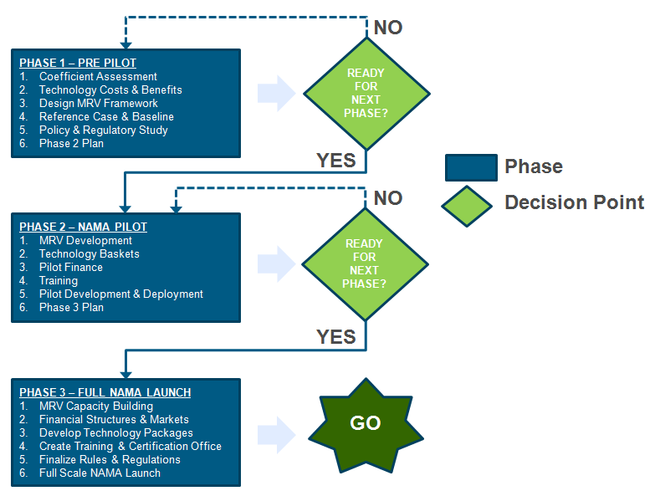

Phase 1: Pre Pilot Activities
The activities around Phase 1 (Pre Pilot) are focused on creating a framework while implementing processes and structures for making the NAMA “Pilot Ready”. Table 10 summarizes the envisioned activities in Phase 1 along with responsible parties, funding and envisioned period of execution. Since there is currently insufficient information regarding the emissions coefficients for the four sectors (new housing, water, solid waste and public lighting) that comprise an urban community as defined in this proposal, the first activity in this phase will look to quantify these coefficients for the four climate zones in Mexico. It is anticipated that more than four sets of coefficients for each sector may be required depending upon variations based on geographic location. For this analysis, the Urban NAMA will also evaluate the actions taken by other sustainable cities initiatives to identify best practices and lessons learned.
In parallel, a comprehensive list of technologies (i.e. expanded version of what has been presented in Table 6) must be compiled along with the associated costs for these technologies. It is assumed that this list will be customized based on variations (in technologies and costs) that result from communities being in different climate zones. The benefits that result from deploying each technology should also be quantified including both GHG and non GHG benefits (e.g. jobs created, health impacts etc.).
The quantification of benefits becomes an important element in support subsequent policy and regulatory discussions at every phase of the Urban NAMA implementation. A preliminary policy and regulatory framework is required to understand what enablers exist to support pilot and full scale implementation while also identifying gaps that must be addressed before these phases are launched. Development of a credible Phase 2 plan that includes budget estimates, resources required and timelines for implementation is also critical in assuring that appropriate commitments are secured before implementation of the pilot. Finally, conducting a review of the work output from Phase 1 activities along with a critical review of the Phase 2 plan will help in assuring that all of the pieces are in place before proceeding to pilot scale implementation. This step serves as an important check point to address any gaps in terms of deliverables that resulted from the activities prescribed in this phase through allocation of additional resources or time as necessary.
Table 10: Phase 1 Activities Summary
Activity | Description | Possible Responsible Parties | Funding & Execution Period
1) Emission Coefficients Assessments | This activity will focus on estimating the applicable life cycle emission coefficients for each sector in the Urban NAMA. | Execution – SEMARNAT / CONAVI, Technical Consultants  Review – International Partners, Universities | Period: ~1-3 months  Funding: ~$200,000
2) Technology Costs and Benefits Analysis | This activity will focus on identifying all applicable emission reduction technologies in each sector and identifying the short term and long term forecasted costs (capital and operating) and benefits (GHG, economic, societal etc.). | Execution – SEMARNAT / CONAVI, Technical Consultants  Review – State and Local Agencies, International Partners, World Bank, | Period: ~3-6 months  Funding: ~$200,000
3) Design of MRV Framework | This activity will focus on articulating the actual method of collecting measurements of power, water, fuel and waste at the community scale and identify necessary data to convert these measures in the GHG emissions. | Execution – SEMARNAT / CONAVI, Technical Consultants  Review – State and Local Agencies, International Partners | Period: ~ 6-9 months  Funding: ~$250,000
4) Reference Case and Crediting Baseline Development | This activity will focus on developing the reference case emissions forecasts as well as the crediting baseline for an urban community. This will also require a clear definition of boundary conditions and size of the urban community. The recommended periods for revision of reference case and crediting baseline will also be defined. | Execution – SEMARNAT / CONAVI, Technical and Policy Consultants  Review – State and Local Agencies, International Partners, World Bank, INEGI | Period: ~3-6 months (because of some dependency on activity 2)  Funding: ~$300,000
5) Policy and Regulatory Framework | This activity will focus on identifying policy and regulatory gaps that need to be addressed before the launch of a full scale Urban NAMA. | Execution – SEMARNAT / CONAVI, Policy and Law Consultants  Review – Federal, State and Local Government | Period: ~3-6 months  Funding: ~$100,000
6) Phase 2 Plan Development | This activity will focus on revising/developing a set of activities, budget and schedule for Phase 2. This plan should also factor in any structural changes in the organization as well as additional resources (e.g. IT, people) required for deployment of the Urban NAMA pilot in Phase 2. | Execution – SEMARNAT / CONAVI  Review – SEMARNAT / CONAVI, Independent third party | Period: ~1-2 months  Funding: ~$200,000
7) Phase 1 Results and Phase 2 Plan Review | This activity will focus on reviewing Phase 1 results, assessing the credibility of the Phase 2 plan and determining if the Urban NAMA is ready to proceed to Phase 2. | Execution – SEMARNAT / CONAVI  Review – Federal, State and Local Government, World Bank, Other Funding Agencies | Period: ~1-2 months  Funding: ~$200,000
Totals for Phase 1 |  |  | Period: ~9 months  Funding: ~$1,500,000
The goal successful completion of these tasks will mean that the Urban NAMA is pilot-ready. However, additional work will be needed for the roll-out of the program on the national scale.

Phase 2: NAMA Pilot Activities
The core focus of this Phase is to develop and deploy Urban NAMA pilots in the four climate zones in Mexico (as suggested in an earlier part of this document). Table 10 summarizes the envisioned activities in Phase 1 along with responsible parties, funding and envisioned period of execution. Clearly as discussed in earlier chapters an MRV framework to adequately address what is proposed under the Urban NAMA does not exist today. Parallel activities that concurrently develops the MRV framework along with the technology bundles for each sector along with cross sector bundles is an important step that must be completed before implementation of pilot Urban NAMA communities. This will ensure that there is a clear standard for quantifying the costs, GHG and non GHG benefits associated with various interventions. Estimates of the costs and benefits will also feed into the creation of a financial infrastructure to support the pilot.
An evaluation of the financial infrastructure needs for pilot and full scale implementation will need to be executed to provide some transparency on how financial incentives are aligned for implementing bodies. It will also help define market changes that need to occur especially as considerations arising around a full scale credited NAMA launch in the next phase. Prior to pilot deployment selected personnel within the NAMA office and vendors qualified to provide services for the pilot are trained in the basics around MRV, financial incentives, communication protocols etc. These elements must be in place and there should be strong confidence that adequate training has been provided before the activity enters into the stage of pilot implementation and monitoring. Finally, similar to Phase 1, a Phase 3 plan and review of Phase 2 activities needs to be conducted to identify and address gaps prior to entering the full scale Urban NAMA implementation phase.
Table 11: Phase 2 Activities Summary
Activity | Description | Possible Responsible Parties | Funding & Execution Period
1) MRV Development | This activity will focus on creating and deploying a measurement, reporting and verification system for the Urban NAMA in the NAMA Office. The organizational structure to facilitate the MRV, tracking emissions reductions etc. will also be outlined as part of this activity. | Execution – SEMARNAT / CONAVI, Technical Consultants, Municipality Service Providers  Review – International Partners, NAMA Office, Independent third party, Municipality Service Providers | Period: ~3-6 months  Funding: ~750,000 (estimate $125,000 per sector plus $250,000 for setting up IT infrastructure etc.)
2) Technology Baskets | This activity will focus on identifying baskets of technologies that fit well within the MRV framework and can achieve quantifiable emissions reductions worthy of subsequent crediting. The costs and benefits of the various technology baskets should also be quantified for future reporting purposes. The analysis should also determine if there are economies of scale benefits in combining technologies into baskets. | Execution – SEMARNAT / CONAVI, Technical Consultants  Review – SEMARNAT / CONAVI, Municipal Service Providers, Independent third party | Period: ~3-6 months  Funding: ~$750,000 (estimate about $150,000 per sector plus additional $150,000 to determine aggregation benefits)
3) Pilot Financial Infrastructure | This activity will focus on creating the financial infrastructure needed for the pilot and proposing potential financial structures for a full scale urban NAMA. | Execution – SEMARNAT / CONAVI, Financial Consultants  Review – SEMARNAT / CONAVI, Development Banks, Other Local and International Financial Institutions | Period: ~3-6 months  Funding: ~$250,000
4) Training | This activity will focus on training personnel within the NAMA office and service providers selected to implement the NAMA on the technology baskets, MRV and the financial operations related to the NAMA pilot. | Execution – SEMARNAT / CONAVI, Technical Consultants, Muni Service Providers  Review – SEMARNAT / CONAVI, Municipal Service Providers | Period: ~3months  Funding: ~$200,000 (assume $50,000 per sector)
5) Pilot Development and Deployment | This activity will focus on identifying and implementing four Urban NAMA pilot communities (one in each climate zone). Technology baskets should be identified and the MRV systems and financing structures must be in place prior to pilot deployment. The NAMA office would issue an RFP to select service providers for each NAMA community. The method for periodic evaluations and gauging progress must also be finalized and implemented at this stage. | Execution – SEMARNAT / CONAVI, Consultants, Service Providers  Review – SEMARNAT / CONAVI, Consultants, Independent third party | Period: ~3 months for development and selection of vendors. ~1 year of performance verified.  Funding: ~$3,000,000 ($200,000 for development, $700,000 per community for deployment and progress monitoring. Community assumed to be 100 units and $7000 spent in aggregate per unit)
6) Phase 3 Plan Development |  | Execution – SEMARNAT / CONAVI  Review – Federal, State and Local Government, World Bank, Other Funding Agencies | Period: ~1-2 months  Funding: ~$25,000
7) Phase 2 Results and Phase 3 Plan Review | This activity will focus on reviewing Phase 2 results, assessing the credibility of the Phase 3 plan and determining if the Urban NAMA is ready to proceed to Phase 3. | Execution – SEMARNAT / CONAVI  Review – Federal, State and Local Government, World Bank, Other Funding Agencies | Period: ~1-2 months  Funding: ~$25,000
Totals for Phase 2 |  |  | Period: ~24 months  Funding: ~$5,000,000

Phase 3: Full Scale Urban NAMA Activities
The core focus of this Phase is to refine and/or create all of the systems and processes to deploy a full scale Urban NAMA. Table 12 summarizes the envisioned activities in Phase 3 along with responsible parties, funding and envisioned period of execution. We have not attempted to qualify funding requirements in this phase because there is a large dependency on what the scale of national roll out is likely to be. Our expectation is that a scaled program will be in the $100 M+ range encompassing several communities across Mexico. A majority of the activities that are identified in this Phase are similar to those identified in Phase 2 with similar justification. The MRV system will enter the capacity building mode which focuses on identifying program, process and resource changes needed to support the national scale, credited Urban NAMA.
Based on the findings from Phase 2, the technology baskets could be further combined into larger packages that can be applied across various regions in Mexico. These baskets, along with data collected during the pilot phase, can be used to establish a quantitative estimate of the full program impact in terms of mitigation and cost.
A training and certification office that provides internal personnel and approved vendors with the necessary knowledge and tools for NAMA implementation must also be created in this Phase. Finally, some of the critical activities in this phase focus on assuring that the financial structures, markets and associated rules and regulations are all in place prior to the launch of the national Urban NAMA. Ideally, market and regulatory transparency along with expedited processes should assure that the credited national Urban NAMA becomes a self sustaining initiative requiring minimal additional government funding (i.e. minimal need for subsidies, grants, tax incentives etc. and government only provides funds to maintain adequate resources in the NAMA office). A review conducted at this Phase will assure that all the parts are in place before the national scale Urban NAMA is launched.
Table 12: Phase 3 Activities Summary
Activity | Description | Possible Responsible Parties | Funding & Execution Period
1) MRV Capacity Building | This activity will focus on revising and expanding the pilot MRV system to handle a national program roll out. | Execution – SEMARNAT / CONAVI, Technical Consultants, Municipality Service Providers  Review – International Partners, SEMARNAT / CONAVI, Independent third party, Municipality Service Providers | Period: ~3-6 months  Funding: TBD
2) Financial Structures and Markets | This activity will focus on finalizing the financial structures and associated credit markets to facilitate a national program roll out. | Execution – SEMARNAT / CONAVI, Financial Consultants  Review – SEMARNAT / CONAVI, Development Banks, Other Local and International Financial Institutions | Period: ~3-6 months  Funding: TBD
3) Develop Technology Packages | This activity will focus on further customizing technology baskets developed in the previous stage into larger packages that can be applied across urban environments in the country. | Execution – SEMARNAT / CONAVI, Technical Consultants  Review – SEMARNAT / CONAVI, Municipal Service Providers, Independent third party | Period: ~3-6 months  Funding: TBD
4) Create Training & Certification Office | This activity will focus on creating a training and certification office to support a national Urban NAMA. | Execution – SEMARNAT / CONAVI, Technical Consultants, Muni Service Providers  Review – SEMARNAT / CONAVI, Muni Service Providers | Period: ~3-6 months  Funding: TBD
5) Finalize Rules and Regulations | This activity will focus on finalizing the rules and regulations needed to support a national Urban NAMA and crediting of emissions reductions. | Execution – SEMARNAT / CONAVI, Policy and Law Consultants  Review – Federal, State and Local Government | Period: ~3-6 months  Funding: TBD
6) Full Scale NAMA Launch | This activity is focused on determining if all of the systems, processes and regulations are in place to launch a full scale Urban NAMA in Mexico. | Execution – SEMARNAT / CONAVI  Review – Federal, State and Local Government, World Bank, Other Funding Agencies | Period: ~1-2 months  Funding: TBD
Totals for Phase 3 |  |  | Period: ~3-6 months  Funding: ~TBD

Schedule for Implementation
Mainstream implementation of the Urban NAMA by the end of 2016 requires a few select pilot communities to be in place by 2014, and much of the implementation infrastructure to be put in place in 2013. After the presentation and subsequent approval of the MRP in late 2012, the design for the Urban NAMA will incorporate the comments of the framework, stakeholders and potential funders. In addition, the MRV and funding for the Pilot should be further investigated to ensure a quick roll out of that phase.
By early 2013, the official implementation phase of the Urban NAMA Pilot should kick off. Most important early on will be the identification of one or several pilot communities that are well suited to demonstrate the Urban NAMA concept. The situation on the ground in the pilot communities will help instruct any policy, regulatory, and institutional actions and permit appropriate lead time.
Figure 13: Gantt chart of the Implementation Schedule
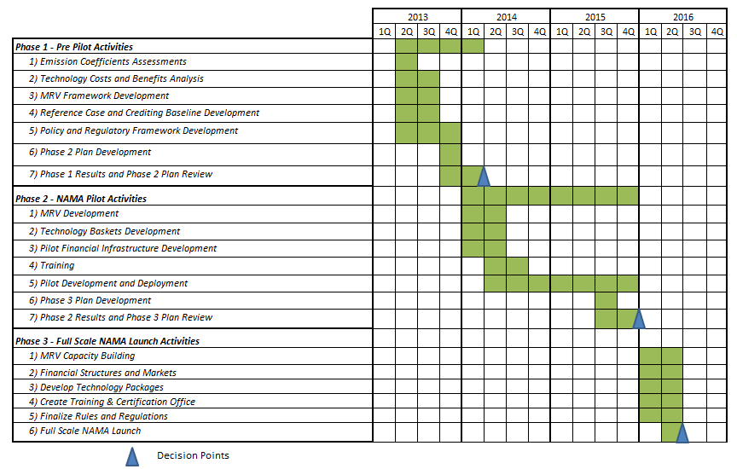
Figure 13 provides an initial proposed schedule for the three phases of activity building up to the launch of a full scale Urban NAMA pilot in Mexico. Assuming a 2013 start, it is anticipated that the pilots can be deployed and performance verified by mid-to-end 2015 with a larger programmatic roll out in 2016. There can be significant changes that occur to this schedule as one would expect depending on variation in completion of sub tasks, ability to secure funding, results from the review conducted at each stage etc.

CONAVI, SEMARNAT. Supported NAMA for Sustainable Housing in Mexico - Mitigation Actions and Financing Packages. Mexico City 2011
CONAVI, USEPA, Centro Mario Molina, Thomson Reuters Point Carbon
Correspondence with CONAVI August 29, 2012
IMCO. Programa Especial de Cambio Climático para el periodo 2012-2020 con acciones adicionales y análisis de potencial. Programa de las Naciones Unidas para el Medio Ambiente. Mexico City 2011
IMCO. Programa Especial de Cambio Climático para el periodo 2012-2020 con acciones adicionales y análisis de potencial. Programa de las Naciones Unidas para el Medio Ambiente, (2011)
CONAVI
CONAVI, SEMARNAT. Supported NAMA for Sustainable Housing in Mexico - Mitigation Actions and Financing Packages. Mexico City 2011
Thomson Reuters Point Carbon
United Nations, Department of Economic and Social Affairs, Population Division (2012). World Urbanization Prospects: The 2011 Revision, CD-ROM Edition.
http://www.ghgprotocol.org/city-accounting
United Nations, Department of Economic and Social Affairs, Population Division: World Urbanization Prospects, the 2011 Revision. New York 2012
http://www.iclei.org/
http://www.worldmayorscouncil.org/
Source: Point Carbon: Carbon Project Manager
IzN Friedrichsdorf
This proposed structure is notional and subject to change
This proposed structure is notional and subject to change
CONAVI, SEMARNAT. Supported NAMA for Sustainable Housing in Mexico - Mitigation Actions and Financing Packages. Mexico City 2011
Proposed metrics are indicative only and subject to change.
An important consideration here is whether or not the mitigation actions are fixed infrastructure or whether they can be removed from the community. For example, in some cases the efficient appliances installed under the green mortgage program sold or stolen, decreasing the impact these actions below their technical potential.
TRPC assessment based on CDM & Voluntary carbon methodologies

