Market Readiness Assessment & Rationale for Focusing on the Urban System

Mexico is pursuing aggressive action to curb greenhouse gas (GHG) emissions growth through sustainable economic development. To achieve these goals, the country is instituting a range of actions, including the deployment of sustainable urban environments discussed in this report.
Increasing trends in population growth and urbanization, combined with financial incentives that result in urban sprawl are increasing the pressure on municipal governments to deliver effective and efficient public services. Without additional action, as many as 5-10 million new homes will be constructed in Mexico over the coming decade, resulting in more than 70 million tons of GHG emissions by 2020.
The Urban Nationally Appropriate Mitigation Action (NAMA) proposed in this document directly addresses this growing source of GHG emissions by building on existing sustainable housing programmes operated by the Comisión Nacional de Vivienda (CONAVI) that provide loans and subsidies to community developers and home owners that install efficient appliances in the new homes. The Urban NAMA expands the operational and financial scope of these initiatives to cover additional target areas covering the entire range of community development including building envelope, water delivery, sewage, public lighting, and municipal solid waste.
The Urban NAMA achieves these objectives by attracting carbon finance through a supporting Monitoring, Reporting, and Verification (MRV) framework that enables performance based payments and the potential creation of carbon credits. The NAMA leverages these revenue streams to access additional commercial and development finance to deploy nation-wide sustainable investments. Furthermore, the NAMA creates and provides technical guidance and training to ensure that sustainable technologies achieve their full potential.
This document outlines the role of the Urban NAMA and the needs that it addresses, clearly explaining its relationship to sustainability actions and regulatory initiatives within Mexico. Additional explanation is provided describing how the proposed NAMA will build on and synergize with these programmes and avoid double counting of emissions reductions.
The report evaluates key design elements of the Urban NAMA and the operational, financial and technical development needed to implement this initiative nationwide by 2017.
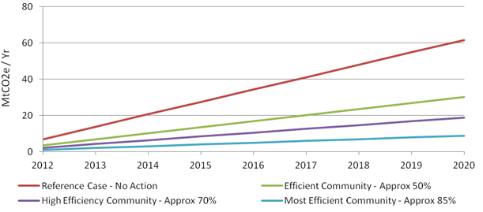
The Mexican population is projected to grow from just over 110 million in 2010 to more than 160 million by 2050. At that rate it is expected that more than 11 million new residences will be required by 2030, with 9 million existing homes requiring major retrofit. Most of this growth will occur in urban areas which will consume nearly 50% of the country’s energy resources and 60% of the hydrological resources over the next 20 years.
Low emission urban communities can help achieve sustainable and urban development goals through change in policy approaches and decision-making. This can be done by prioritizing life-cycle and performance metrics, and engaging in more integrated planning processes.
Under the current incentive structure, housing developers purchase cheap tracks of land far from urban centres for their major developments. Municipal governments with severe budget constraints are unable to afford to up-front capital cost of appropriate and efficient urban services. Because the developers end their relationship with the community once the homes are sold, there is no incentive on their part to provide access to efficient and appropriate services. The result is that hundreds of thousands of homes are built each year with poorly implemented municipal services and unnecessary GHG growth.
Mexico has already taken action to address climate change and reduce growth in GHG emissions. Two key initiatives in this regard are the PECC initiated in 2009, and the Climate Change Law passed April 19, 2012.
The PECC having successfully completed its 2009-2012 phase, has for 2013-2020 laid out a plan to reduce emissions by more than 125 Million tons per year by 2020 from a business as usual projection of nearly 880 million tons.
The Urban NAMA is aligned with and complementary to both the PECC and Climate Change Law. The Fund described in the Climate Change Law could be used to fund technology deployment and capacity building, and could be an important conduit for rising funding through the sale of carbon credits. Furthermore, the implementation of an Urban NAMA would advance key goals laid out in the Law, including:
- Promotion of sustainable production and consumption patterns across the economy;
- Promotion of energy efficiency practices, particularly in real estate and assets of agencies and entities operated by federal, state, and local governments;
- Promotion of renewable energy across the economy;
- Drafting, executing, and complying with urban development plans that comprise energy efficiency and mitigation criteria for direct and indirect emissions;
- Issuing regulatory provisions to regulate the construction of sustainable buildings, including the use of environmentally friendly materials and energy efficiency.
The Urban NAMA also addresses emissions reduction opportunities that are aligned with PECC actions, in particular efficiency housing and biogas generate from sewage. There are, however, additional actions that the Urban NAMA will take build on what is included in the current plan.
The goal of the Urban NAMA is to achieve credited GHG emissions reductions through deployment of sustainable urban communities at the national scale. Currently, two of the most successful sustainable development programmes in Mexico are operated by CONAVI. These programmes, namely ‘Hipoteca Verde’ (‘Green Mortgage’) and ‘Ésta es tu casa’ (‘This is your house’) provide supplemental income to cover the incremental cost of energy efficient equipment. Through their initiatives, CONAVI has established financial and operational relationships with community developers, and developed technical guidance covering the types of technologies that qualify for the financial incentives.
Preliminary Design of a Scaled-Up Urban NAMA
The Urban NAMA as it is defined in this document covers community scale mitigation actions applied for new, green field residential communities across Mexico that (1) reduce demand for delivered services, or; (2) improve the emissions efficiency of delivered services. The sectors that comprise the community include: New Housing, Waste, Water and Public Lighting.
Financial Design Elements
The Urban NAMA blends public funds, climate finance and carbon credits to leverage commercially funding through PPPs to support sustainable development. Carbon credits are a key element to the success of the programme because they allow the Federal Government to monetize the climate benefits generated under the Urban NAMA, creating an additional revenue stream that can be used to strengthen the financial case for low carbon investments made by community developers and private financial institutions.

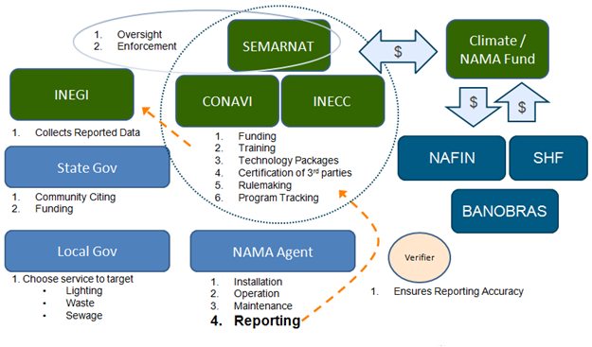
However, the Urban NAMA will not be solely supported through the sale of carbon credits, nor are saleable credits the only source of economic value that will be generated. It is expected that “unilateral” funding from the Mexican government will be supplied and partly funded by the green fund described in the Climate Change Law, and possibly funded through savings to the government resulting from decreasing energy subsidies.
Elements of the NAMA may be “supported” through loans and grants from development banks, multilateral institutions, and foreign governments. Under a performance-based “supported” paradigm, the measured impacts of the NAMA are used to attract sustainable development funding without the issuance of credits.
Monitoring, Reporting & Verification
The Urban NAMA will be designed around an MRV system that is simple enough to deploy quickly and at a manageable cost. The next phase will need to explore in greater depth how to find an adequate balance between an approach which is simple but which may not be robust or precise; and one that is comprehensive with greater technical certainty, but which creates transaction costs that disqualify many opportunities. The Urban NAMA must seek to balance the need for robust and reliable emission reduction estimates and the need to maintain flexibility, simplicity and cost-effectiveness of the MRV system of the proposed NAMA.
NAMA Potential & Strategy for Implementation
The implementation of a credited NAMA in Mexico will require addressing the following gaps:
- Definition of urban community boundary conditions, associated reference case emissions footprint and definition of an appropriate baseline crediting scheme;
- Identification of applicable emission reduction technologies for each sector and the associated costs and benefits (including GHG reductions, economic benefits, social benefits etc.). This is especially critical to quantify for the waste and water sectors;
- Development of measurement methodologies, identification of variables to be tracked, evaluation of data availability and reliability;
- Definition of technology bundles in each sector that can be applied to reduce emissions and produce verifiable credits;
- Development and deployment of organizational infrastructure required to manage the NAMA.
- Establishment of administrative boundaries, roles and responsibilities;
- Development and deployment of financial infrastructure to generate NAMA implementation funds and for establishing a financial viable crediting scheme;
- Development and deployment of training and certification standards for technology bundles used to implement the NAMA;
- Identification of policy and regulatory changes that must be implemented to facilitate the deployment of a credited Urban NAMA.
A three phase process for NAMA implementation that comprise of: 1) Pre pilot activities, 2) NAMA pilot activities and 3) Full scale NAMA launch activities have been summarized in. The decision points between phases are meant to serve as an opportunity to redirect the initiative as necessary through revision of activities, addition of activities or simply as a holding point until all elements are in place (e.g. regulatory changes, funding, personnel in NAMA office etc.) for successful execution of the next phase.
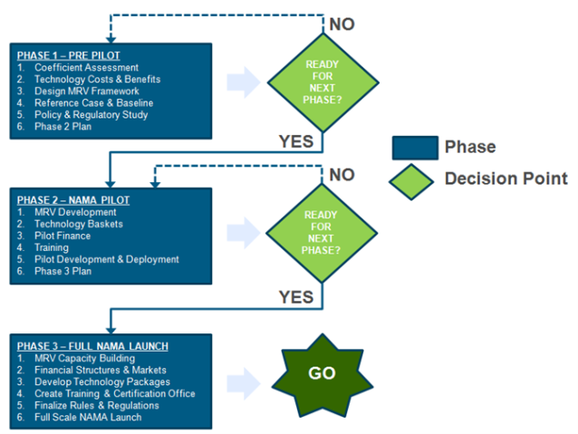
The World Bank (Projects for Market Readiness (PMR)
The PMR Programme of the World Bank explores through a collegiate body new climate finance mechanisms post Kyoto Protocol. The first programmes presented to the PMR Secretariat were proposed for Chile, China, Costa Rica and Mexico. Especially Mexico with the Urban NAMA as main proposal focusses on generating instruments for emissions reduction creating market mechanisms for participant countries.
For the consolidation of the Urban NAMA Programme, representatives from the National Housing Commission (CONAVI) have met with World Bank representatives of the Partnership for Market Readiness (PMR) as well as consultants and representatives from Environment Canada end of June 2012 in Washington D.C. The objective of the meeting was to establish the general framework of the Urban NAMA, the preparation of the document for the executive board of the World Bank, the definition of actions for implementation as well as responsibilities and key stakeholders that will be part of the programme.
The proposal for the Urban NAMA will be evaluated in March 2013 by the PMR Secretariat to define resources for the technical design. The expected resources are around 1.5 Mio USD for the first phase and 4.5 Mio USD for the implementation phase.

